**Chapter: 01**

**INTRODUCTION**

* 1. **Introduction:**

Heating, ventilation, and air conditioning (HVAC) is the technology of indoor and vehicular environmental comfort. HVAC system design is a sub discipline of mechanical engineering, based on the principles of thermodynamics, fluid mechanics and heat transfer. HVAC system is considered as a low-grade energy usage. So, it is not advisable to use high grade energy such as fossil fuels. Hence research has been going to substitute its usage with low-grade energy such as solar or wind energy.

HVAC is an important part of residential structures such as single family homes, apartment buildings, hotels and senior living facilities, medium to large industrial and office buildings such as skyscrapers and hospitals, vehicles such as cars, trains, airplanes, ships and submarines, and in marine environments, where safe and healthy building conditions are regulated with respect to temperature and humidity, using fresh air from outdoors.

Ventilating or ventilation (the V in HVAC) is the process of exchanging or replacing air in any space to provide high indoor air quality which involves temperature control, oxygen replenishment, and removal of moisture, odours, smoke, heat, dust, airborne bacteria, carbon dioxide, and other gases. Ventilation removes unpleasant smells and excessive moisture, introduces outside air, keeps interior building air circulating, and prevents stagnation of the interior air.

Ventilation includes both the exchange of air to the outside as well as circulation of air within the building. It is one of the most important factors for maintaining acceptable indoor air quality in buildings. Methods for ventilating a building may be divided into mechanical/forced and natural types.[2]

The three major functions of heating, ventilation, and air conditioning are interrelated, especially with the need to provide thermal comfort and acceptable indoor air quality within reasonable installation, operation, and maintenance costs. HVAC systems can be used in both domestic and commercial environments. HVAC systems can provide ventilation, and maintain pressure relationships between spaces. The means of air delivery and removal from spaces is known as room air distribution.[3]

**1.2 Need of this project:**

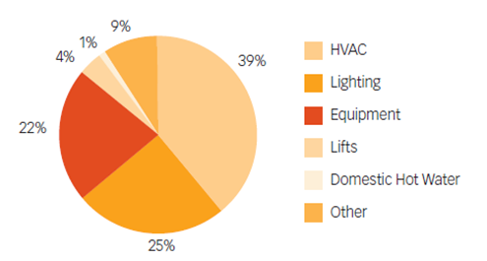

Fig1.1: Energy consumption of general commercial building

Proper heating, ventilation and air conditioning are key to providing a comfortable and healthy work environment. Commercial HVAC systems account for about 40% of the energy used in commercial buildings. Collectively, these systems account for approximately 40% of the electricity used in commercial buildings currently used HVAC systems consume a major chunk of energy supplied to a building system. Not only it costs high amounts of energy but it also poses a threat to environment due to use refrigerants like R410a, R407c and R134a having large values of GWP (global warming potential). The cost required for instalment of a standard HVAC system is exorbitantly high.

Considering all of the mentioned disadvantages, it therefore demands a new HVAC system, wherein either all or some of the components of the present system should be incorporated with more dynamic and efficient techniques working on non-conventional energy sources like TABS, natural convection and solar energy.

**1.3Aim and Objective:**

Aim of the project is to design HVAC system with help of solar energy and natural convection to reduce energy consumption, to develop more efficient integrated system which is more eco-friendly than Conventional HVAC system.

The end product of this project is design of HVAC system which collaborates in some non-conventional methods with current modern methods to increase efficiency such as TABS, solar VARS and vapor adsorption chillers (not absorption).

**1.4 Problem Definition:**

1.Selection of a practical HVAC system.

2.Calculation of heat load and energy consumption using conventional HVAC systems.

3.Selection of glass and its properties.

4.Selection various HVAC system like chiller etc according to heat load.

5.Cost calculation of conventional HVAC system.

6.Study of latest available non-conventional HVAC systems.

7.Selection of most effective techniques and methods.

8.Calculation of energy obtained by sun using solar cell.

9.Mathematical modelling of Thermally active building system (TABS).

10. Simulation of system to validate result.

11.comparison of Conventional and non-conventional system.

**1.5 History of HVAC:**

HVAC is based on inventions and discoveries made by Nikolay Lvov, Michael Faraday, Willis Carrier, Edwin Ruud, Reuben Trane, James Joule, William Rankine, Sadi Carnot, and many others. Multiple inventions within this time frame preceded the beginnings of first comfort air conditioning system, which was designed in 1902 by Alfred Wolff (Cooper, 2003) for the New York Stock Exchange, while Willis Carrier equipped the Sacketts-Willems Printing Company with the process AC unit the same year. Coyne College was the first school to offer HVAC training in 1899. The invention of the components of HVAC systems went hand-in-hand with the industrial revolution, and new methods of modernization, higher efficiency, and system control are constantly being introduced by companies and inventors worldwide.

Since the 1980s, manufacturers of HVAC equipment have been making an effort to make the systems they manufacture more efficient. This was originally driven by rising energy costs, and has more recently been driven by increased awareness of environmental issues. Additionally, improvements to the HVAC system efficiency can also help increase occupant health and productivity. There are several methods for making HVAC systems more efficient.

**1.6 HVAC industry and standard:**

The HVAC industry is a worldwide enterprise, with roles including operation and maintenance, system design and construction, equipment manufacturing and sales, and in education and research. The HVAC industry was historically regulated by the manufacturers of HVAC equipment, but regulating and standards organizations such as HARDI, ASHRAE, SMACNA, ACCA, Uniform Mechanical Code, International Mechanical Code, and AMCA have been established to support the industry and encourage high standards and achievement.

The starting point in carrying out an estimate both for cooling and heating depends on the exterior climate and interior specified conditions. However, before taking up the heat load calculation, it is necessary to find fresh air requirements for each area in detail, as pressurization is an important consideration.

**1.6.1 International standard:**

ISO 16813:2006 is one of the ISO building environment standards. It establishes the general principles of building environment design. It takes into account the need to provide a healthy indoor environment for the occupants as well as the need to protect the environment for future generations and promote collaboration among the various parties involved in building environmental design for sustainability. ISO16813 is applicable to new construction and the retrofit of existing buildings.

The building environmental design standard aims to:

provide the constraints concerning sustainability issues from the initial stage of the design process, with building and plant life cycle to be considered together with owning and operating costs from the beginning of the design process; assess the proposed design with rational criteria for indoor air quality, thermal comfort, acoustical comfort, visual comfort, energy efficiency and HVAC system controls at every stage of the design process; iterate decisions and evaluations of the design throughout the design process.

India

**1.6.2 ISHRAE:**

The Indian Society of Heating, Refrigerating and Air Conditioning Engineers (ISHRAE) was established to promote the HVAC industry in India. ISHRAE is an associate of ASHRAE. ISHRAE was started at Delhi in 1981 and a chapter was started in Bangalore in 1989. Between 1989 & 1993, ISHRAE chapters were formed in all major cities in India.

ISHRAE works in the National interest with various Govt. Ministries/Departments, e.g. in the development of Standards & drafting of NBC for BIS, working on ECBC with BEE, with Ozone Cell of MoEFCC, on refrigerant gases. ISHRAE is a member & active supporter of National Centre for Cold Chain development (NCCD) Ministry of Agriculture & works closely with NCCD on refrigeration.

ISHRAE is also working in close co-operation with other similar Societies & Organizations, both at national and international level, for the promotion and development of issues like Sustainability, Green Buildings, Energy Efficiency, Environmental Responsibility, Indoor Air Quality, Fire & Safety. Interaction with Think-tanks & NGOs like NRDC, CEEW, TERI, CSE & UN bodies like UNDP/UNEP is a regular feature. ISHRAE is looked upon as a repository of technical knowledge in the HVAC&R & Building Industry field by peer Organizations & the Govt. of India.

**1.6.3 ASHRAE:**

The American Society of Heating, Refrigerating and Air-Conditioning Engineers is a global professional association seeking to advance heating, ventilation, air conditioning and refrigeration (HVAC&R) systems design and construction. Founded in 1894 it now has more than 50,000 members worldwide, composed of building services engineers, architects, mechanical contractors, building owners, equipment manufacturers' employees, and others concerned with the design and construction of HVAC&R systems in buildings. The society funds research projects, offers continuing education programs, and develops and publishes technical standards to improve building services engineering, energy efficiency, indoor air quality, and sustainable development.

ASHRAE was founded in 1894 at a meeting of engineers in New York City, formerly headquartered at 345 East 47th Street, and has held an annual meeting since 1895. Until 1954 it was known as the American Society of Heating and Ventilating Engineers (ASHVE); in that year it changed its name to the American Society of Heating and Air-Conditioning Engineers (ASHAE). Its current name and organization came from the 1959 merger of ASHAE and the American Society of Refrigerating Engineers (ASRE).

Despite having 'American' in its name, ASHRAE is a global organization, holding international events. In 2012, it rebranded itself with a new logo and tagline: "Shaping Tomorrow's Built Environment Today". As of 2015, ASHRAE has more than 50,000 members.

The ASHRAE Handbook is a four-volume resource for HVAC&R technology and is available in both print and electronic versions. The volumes are Fundamentals, HVAC Applications, HVAC Systems and Equipment, and Refrigeration. One of the four volumes is updated each year.

ASHRAE also publishes a set of standards and guidelines relating to HVAC systems and issues, that are often referenced in building codes and used by consulting engineers, mechanical contractors, architects, and government agencies. These standards are periodically reviewed, revised and republished.

Examples of some ASHRAE Standards are:

Standard 34 – Designation and Safety Classification of Refrigerants

Standard 55 – Thermal Environmental Conditions for Human Occupancy

Standard 62.1 – Ventilation for Acceptable Indoor Air Quality (versions: 2001 and earlier as "62", 2004 and beyond as "62.1")

Standard 62.2 – Ventilation and Acceptable Indoor Air Quality in Low-Rise Residential Buildings

Standard 90.1 – Energy Standard for Buildings Except Low-Rise Residential Buildings – The IESNA is a joint sponsor of this standard.

Standard 135 – BACnet - A Data Communication Protocol for Building Automation and Control Networks

Standard 189.1 – Standard for the Design of High Performance, Green Buildings Except Low-Rise Residential Buildings [10]

The society also publishes two magazines: the ASHRAE Journal is issued monthly, and High Performing Buildings Magazine is published quarterly. They contain articles on related technology, information on upcoming meetings, editorials, and case studies of various well-performing buildings.

**1.7 Components of HVAC:**

**1.7.1 Chillers:**

A cooling tower circulates cold water or air to the chiller. Heat exchange occurs between this cold fluid and the warm refrigerant in the chiller. The refrigerant, after being cooled, cools the water entering the chiller. The chilled water is then circulated to the AHU. Chillers are classified as air-cooled and water-cooled chillers.

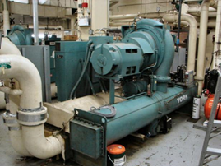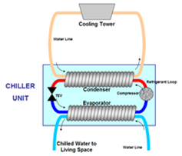

Fig 1.2: Chiller

**1.7.2 Cooling Tower:**

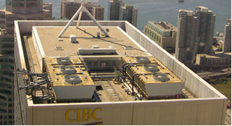 A cooling tower is a heat rejection device used to dispose of unwanted heat from the chiller. The warm water from the chiller is circulated through the cooling tower where evaporative cooling causes heat to be removed from the water and added to the outside air. The cooled water is then piped back to the chiller.

Fig 1.3: Cooling Tower

**1.7.3 Air Handling Unit:**

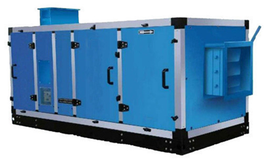An air handling unit (AHU) regulates the flow of cool air and used air through ducts into and from the system. It consists of a supply duct, air filter, cooling coils and blower. The AHU draws air from the surroundings through the supply duct. It is then filtered and cooled and sent to the ducts to supply to the system. The used air from the system enters the AHU and is discarded to the surrounding.

Fig 1.4: AHU

**1.7.4 Ducts:**

Ducts are passages in an HVAC system for delivery and removal of air in the system. Ducts are conduits or passages used in heating, ventilation, and air conditioning (HVAC) to deliver and remove air. The needed airflows include, for example, supply air, return air, and exhaust air. Ducts commonly also deliver ventilation air as part of the supply air.

1.8 Use of Solar Energy in HVAC system:

The method of using solar energy in HVAC system is through the use of Photo-Voltaic (PV) cells to generate electricity that can be used to power HVAC units like compressors etc.

The solar power systems can be classified into two types: (i) Grid-connected system, and (ii) Stand-alone system.

The grid connected type is designed to operate parallel to the electricity grid. When the output of the solar system is less than what is required, then the building would be drawing power from the electric grid. When the output of the solar system is more than required, the surplus output can be fed to the grid which will cause decrease in the electricity bills as per the tariffs. The major disadvantage of this type is the requirement of a smart meter and the power distributor may restrict the size of the system to install.

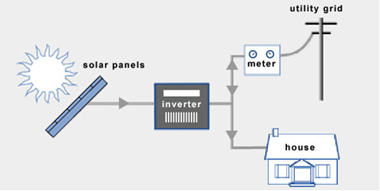

Fig 1.5: Grid connected solar system

The stand-alone type, on the other hand, is not connected to the grid. The power generated is stored in batteries and this is used to run all the electrical loads. The major disadvantage of this type is that there is no backup if the solar system fails and cost of batteries.

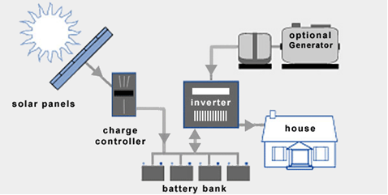

Fig 1.6: Stand-alone solar system

**1.8 Natural Ventilation:**

The flow of air into and out of an indoor space, without the use of any mechanical device or system, is known as natural ventilation. The natural flow of air takes place as a result of the pressure differences created from natural forces. It can be broadly classified into:

(i) Wind driven ventilation, and

(ii) buoyancy driven ventilation.

In wind driven ventilation, the pressure difference is created by wind flowing around the building and windows in the building which allows air to flow through it. In buoyancy driven ventilation, the flow occurs due to the fact that hot air is less dense than cold air. Therefore, due to buoyant force, the hot air moves up and results in natural flow of air.

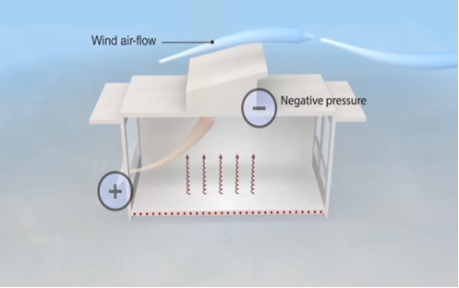

Fig 1.7: Natural Ventilation

**1.9 Indoor Air Quality:**

Indoor air quality is the air quality within and around building structures. Air quality index (AQI) is used to measure air quality by government agencies. It is calculated on basis of pollutant particles concentrations in given sample of air.

In India, the National Air Quality Index (AQI) was launched in New Delhi, which categorized the air into six categories:

(i) Good,

(ii) Satisfactory,

(iii) Moderately polluted,

(iv) Poor,

(v) Very Poor, and

(vi) Severe.

The proposed AQI considers eight pollutants: PM10, PM2.5, NO2, SO2, CO, O3, NH3, and Pb for short term (24-hourly averaging period).

Based on the measured ambient concentrations, a sub-index is calculated for each of these pollutants. The worst sub-index reflects overall AQI.

Table 1.1: AQI categories.

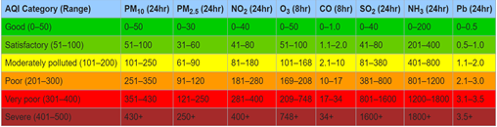

**1.10 conventional design of HVAC system:**

The project deals with designing an HVAC system for a site at Nagpur considering all the climate conditions and factors according to standard procedures.

The Intelligent HVAC System will control Heating, Ventilation and Air Conditioning (HVAC) of the Building Structure with 6 Floor, Basement and Terrace and having 2 wings. The project also consists Full height atrium in between the wings, 4 stair cases and 8 Offices on each floor.

Studies regarding heat loads and various installation equipment along with glass study were put together into this project considering the economic advantage of client as well as the safety of the occupants.

**1.11 site detail:**

Site selected for this project is Nagpur. Nagpur district is a district in the Vidarbha region of Maharashtra state in central India. The city of Nagpur is the district administrative centre. The district is part of Nagpur Division.

Nagpur has tropical savannah climate with dry conditions prevailing for most of the year. It receives about 163 mm of rainfall in June. The amount of rainfall is increased in July to 294 mm. Gradual decrease of rainfall has been observed from July to August (278 mm) and September (160 mm). The highest recorded daily rainfall was 304 mm on 14 July 1994. Summers are extremely hot, lasting from March to June, with May being the hottest month. Winter lasts from November to January, during which temperatures drop below 10 °C (50 °F). The highest recorded temperature in the city was 48 °C on 19 May 2015, while the lowest was 3.9 °C on 16 January 2016.

Table 1.2: Nagpur weather details.

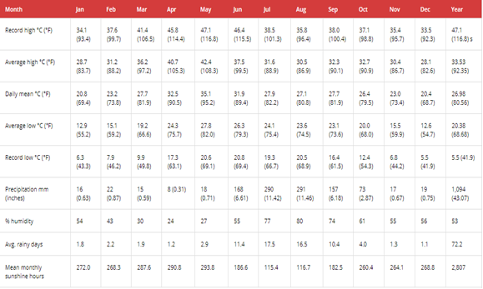

**Chapter: 02**

**LITERATURE SURVEY**

**2.1 About Project:**

The Project Deals with Designing of Non-Conventional HVAC System along with Conventional HVAC System that is not only cost effective but also effective in the process of Heating or Cooling.

In this project HVAC system is designed with the help of solar energy and natural convection to reduce energy consumption, to develop more efficient integrated system which is more eco-friendly than Conventional HVAC system.

**2.2 Heat Load Calculation:**

Heating and cooling load calculations are carried out to estimate the required capacity of heating and cooling systems, which can maintain the required conditions in the conditioned space. To estimate the required cooling or heating capacities, one has to have information regarding the design indoor and outdoor conditions, specifications of the building, specifications of the conditioned space (such as the occupancy, activity level, various appliances and equipment used etc.) and any special requirements of the particular application. For comfort applications, the required indoor conditions are fixed by the criterion of thermal comfort, while for industrial or commercial applications the required indoor conditions are fixed by the particular processes being performed or the products being stored. the design outdoor conditions are chosen based on design dry bulb and coincident wet bulb temperatures for peak summer or winter months for cooling and heating load calculations, respectively.

As the name implies, heating load calculations are carried out to estimate the heat loss from the building in winter so as to arrive at required heating capacities.

Normally during winter months, the peak heating load occurs before sunrise and the outdoor conditions do not vary significantly throughout the winter season. In addition, internal heat sources such as occupants or appliances are beneficial as they compensate some of the heat losses. As a result, normally, the heat load calculations are carried out assuming steady state conditions (no solar radiation and steady outdoor conditions) and neglecting internal heat sources. This is a simple but conservative approach that leads to slight overestimation of the heating capacity. For more accurate estimation of heating loads, one has to take into the thermal capacity of the walls and internal heat sources, which makes the problem more complicated. **Cooling load estimation:**

one has to consider the unsteady state processes, as the peak cooling load occurs during the day time and the outside conditions also vary significantly throughout the day due to solar radiation. In addition, all internal sources add on to the cooling loads and neglecting them would lead to underestimation of the required cooling capacity and the possibility of not being able to maintain the required indoor conditions.

Thus, cooling load calculations are inherently more complicated as it involves solving unsteady equations with unsteady boundary conditions and internal heat sources. For any building there exists a balance point at which the solar radiation (Qsolar) and internal heat generation rate (Qint) exactly balance the heat losses from the building.

Thus, from sensible heat balance equation, at balanced condition:

………… (1)

where UA is the product of overall heat transfer coefficient and heat transfer area of the building, Tin is the required indoor temperature and Tout is the outdoor temperature.

From the above equation, the outside temperature at balanced condition (Tout, Bal) is given by:

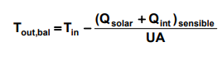 ………… (2)

If the outdoor temperature is greater than the balanced outdoor temperature given by the above equation, i.e., when Tout > Tout, Bal, then there is a need for cooling the building. On the other hand, when the outdoor temperature is less than the balanced outdoor temperature, i.e., when Tout < Tout, Bal, then there is a need for heating the building. When the outdoor temperature exactly equals the balanced outdoor temperature, i.e., when Tout = Tout, Bal, then there is no need for either cooling or heating the building for residential buildings (with fewer internal heat sources), the balanced outdoor temperature may vary from 10 to 18o C. As discussed before, this means that if the balanced outdoor temperature is 18o C, then a cooling system is required when the outdoor temperature exceeds 18o C.

This implies that buildings need cooling not only during summer but also during spring and fall as well. If the building is well insulated (small UA) and/or internal loads are high, then from the energy balance equation above, the balanced outdoor temperature will reduce leading to extended cooling season and shortened heating season. Thus, a smaller balanced outdoor temperature implies higher cooling requirements and smaller heating requirements, and vice versa.

For commercial buildings with large internal loads and relatively smaller heat transfer areas, the balanced outdoor temperature can be as low as 2o C, implying a lengthy cooling season and a small heating season. If there are no internal heat sources and if the solar radiation is negligible, then from the heat balance equation, Tout, Bal = Tin, this implies that if the outside temperature exceeds the required inside temperature (say, 25o C for comfort) then there is a need for cooling otherwise there is a need for heating. Thus, depending upon the specific conditions of the building, the need for either cooling system or a heating system depends.

This also implies a need for optimizing the building insulation depending upon outdoor conditions and building heat generation so that one can use during certain periods free cooling provided by the environment without using any external cooling system.

**Methods of estimating cooling and heating loads:**

Generally, heating and cooling load calculations involve a systematic, stepwise procedure, using which one can arrive at the required system capacity by taking into account all the building energy flows. In practice, a variety of methods ranging from simple rules-of-thumb to complex Transfer Function Methods are used in practice to arrive at the building loads. For example, typical rules-of-thumb methods for cooling loads specify the required cooling capacity based on the floor area or occupancy. Such rules-of-thumb are useful in preliminary estimation of the equipment size and cost. The main conceptual drawback of rules of-thumb methods is the presumption that the building design will not make any difference.

**Assumptions:**

1. Design outside conditions are selected from a long-term statistical database. The conditions will not necessarily represent any actual year, but are representative of the location of the building. Design data for outside conditions for various locations of the world have been collected and are available in tabular form in various handbooks.

2. The load on the building due to solar radiation is estimated for clear sky conditions.

3. The building occupancy is assumed to be at full design capacity.

4. All building equipment and appliances are considered to be operating at a reasonably representative capacity.

The total building cooling load consists of heat transferred through the building envelope (walls, roof, floor, windows, doors etc.) and heat generated by occupants, equipment, and lights. The load due to heat transfer through the envelope is called as external load, while all other loads are called as internal loads. The percentage of external versus internal load varies with building type, site climate, and building design. The total cooling load on any building consists of both sensible as well as latent load components. The sensible load affects dry bulb temperature, while the latent load affects the moisture content of the conditioned space.

**Classification of building based on load:**

Buildings may be classified as externally loaded and internally loaded. In externally loaded buildings the cooling load on the building is mainly due to heat transfer between the surroundings and the internal conditioned space. Since the surrounding conditions are highly variable in any given day, the cooling load of an externally loaded building varies widely.

In internally loaded buildings the cooling load is mainly due to internal heat generating sources such as occupants or appliances or processes. In general, the heat generation due to internal heat sources may remain fairly constant, and since the heat transfer from the variable surroundings is much less compared to the internal heat sources, the cooling load of an internally loaded building remains fairly constant.

Obviously from energy efficiency and economics points of view, the system design strategy for an externally loaded building should be different from an internally loaded building. Hence, prior knowledge of whether the building is externally loaded or internally loaded is essential for effective system design. the total cooling load on a building consists of external as well as internal loads. The external loads consist of heat transfer by conduction through the building walls, roof, floor, doors etc, heat transfer by radiation through fenestration such as windows and skylights.

All these are sensible heat transfers. In addition to these the external load also consists of heat transfer due to infiltration, which consists of both sensible as well as latent components. The heat transfer due to ventilation is not a load on the building but a load on the system. The various internal loads consist of sensible and latent heat transfer due to occupants, products, processes and appliances, sensible heat transfer due to lighting and other equipment.

**Estimation of external loads:**

a) Heat transfer through opaque surfaces: This is a sensible heat transfer process. The heat transfer rate through opaque surfaces such as walls, roof, floor, doors etc. is given by:

**Q(opaque) = CLTD.A.UQ**

where U is the overall heat transfer coefficient and A is the heat transfer area of the surface on the side of the conditioned space. CLTD is the cooling load temperature difference.

Adjustment to the values obtained from the table is needed if actual conditions are different from those based on which the CLTD tables are prepared. For surfaces which are not sunlit or which have negligible thermal mass (such as doors), the CLTD value is simply equal to the temperature difference across the wall or roof.

For example, for external doors the CLTD value is simply equal to the difference between the design outdoor and indoor dry bulb temperatures, Tout-Tin. For interior air-conditioned rooms surrounded by non-air-conditioned spaces, the CLTD of the interior walls is equal to the temperature difference between the surrounding non-air-conditioned space and the conditioned space. Obviously, if an air-conditioned room is surrounded by other air-conditioned rooms, with all of them at the same temperature, the CLTD values of the walls of the interior room will be zero. Estimation of CLTD values of floor and roof with false ceiling could be tricky. For floors standing on ground, one has to use the temperature of the ground for estimating CLTD.

However, the ground temperature depends on the location and varies with time. ASHRAE suggests suitable temperature difference values for estimating heat transfer through ground. If the floor stands on a basement or on the roof of another room, then the CLTD values for the floor are the temperature difference across the floor (i.e., difference between the temperature of the basement or room below and the conditioned space).

This discussion also holds good for roofs which have non-air-conditioned rooms above them. For sunlit roofs with false ceiling, the U value may be obtained by assuming the false ceiling to be an air space. However, the CLTD values obtained from the tables may not exactly fit the specific roof. Then one has to use his judgement and select suitable CLTD values.

b) Heat transfer through fenestration: Heat transfer through transparent surface such as a window, includes heat transfer by conduction due to temperature difference across the window and heat transfer due to solar radiation through the window. The heat transfer through the window by convection is calculated using Eq with CLTD being equal to the temperature difference across the window and A equal to the total area of the window. The heat transfer due to solar radiation through the window is given by:

…………..(3)

where A unshaded is the area exposed to solar radiation, SHGF max and SC are the maximum Solar Heat Gain Factor and Shading Coefficient, respectively, and CLF is the Cooling Load Factor. the unshaded area has to be obtained from the dimensions of the external shade and solar geometry. SHGF max and SC are obtained from ASHRAE tables based on the orientation of the window, location, month of the year and the type of glass and internal shading device.

**Cooling Load Factor (CLF):**

It accounts for the fact that all the radiant energy that enters the conditioned space at a particular time does not become a part of the cooling load1 instantly. As solar radiation enters the conditioned space, only a negligible portion of it is absorbed by the air particles in the conditioned space instantaneously leading to a minute change in its temperature. Most of the radiation is first absorbed by the internal surfaces, which include ceiling, floor, internal walls, furniture etc.

Due to the large but finite thermal capacity of the roof, floor, walls etc., their temperature increases slowly due to absorption of solar radiation. As the surface temperature increases, heat transfer takes place between these surfaces and the air in the conditioned space. Depending upon the thermal capacity of the wall and the outside temperature, some of the absorbed energy due to solar radiation may be conducted to the outer surface and may be lost to the outdoors. Only that fraction of the solar radiation that is transferred to the air in the conditioned space becomes a load on the building, the heat transferred to the outside is not a part of the cooling load.

Thus, it can be seen that the radiation heat transfer introduces a time lag and also a decrement factor depending upon the dynamic characteristics of the surfaces. Due to the time lag, the effect of radiation will be felt even when the source of radiation, in this case the sun is removed. The CLF values for various surfaces have been calculated as functions of solar time and orientation and are available in the form of tables in ISHRAE Handbooks.

**Load due to occupants:**

The internal cooling load due to occupants consists of both sensible and latent heat components. The rate at which the sensible and latent heat transfer take place depends mainly on the population and activity level of the occupants. Since a portion of the heat transferred by the occupants is in the form of radiation, a Cooling Load Factor (CLF) should be used similar to that used for radiation heat transfer through fenestration. Thus, the sensible heat transfer to the conditioned space due to the occupants is given by the equation:

. **Q = (No. Of People) x (Sensible heat gain per person) x CLF**

Table 2.1: Cooling Load Factor (CLF) for glass with interior shading and located in north latitudes (ISHRAE)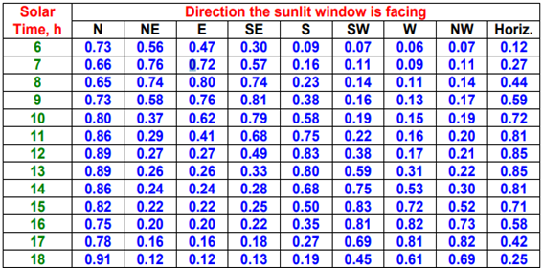

**Load due to lighting:**

Lighting adds sensible heat to the conditioned space. Since the heat transferred from the lighting system consists of both radiation and convection, a Cooling Load Factor is used to account for the time lag. Thus, the cooling load due to lighting system is given by:

**Q= (Installed Lighting wattage) x (Usage factor) x (Ballast Factor) CLF**

The usage factor accounts for any lamps that are installed but are not switched on at the time at which load calculations are performed. The ballast factor takes into account the load imposed by ballasts used in fluorescent lights. A typical ballast factor value of 1.25 is taken for fluorescent lights, while it is equal to 1.0 for incandescent lamps. The values of CLF as a function of the number of hours after the lights are turned on, type of lighting fixtures and the hours of operation of the lights are available in the form of tables in ISHRAE handbooks.

Internal loads due to equipment and appliances: The equipment and appliances used in the conditioned space may add both sensible as well as latent loads to the conditioned space. Again, the sensible load may be in the form of radiation and/or convection. Thus, the internal sensible load due to equipment and appliances is given by:

**Q= (Installed wattage) X (Usage Factor) x CLF**

The installed wattage and usage factor depend on the type of the appliance or equipment. The CLF values are available in the form of tables in ASHARE handbooks.

The latent load due to appliances is given by:

**Q appliance = (Installed wattage) x (Latent heat fraction)**

Table 2.2: shows typical load of various types of appliances

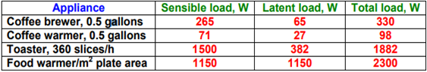

Thus, using the above equations one can estimate the sensible (Qs, r), latent (Ql, r) and total cooling load (Qt, r) on the buildings. Since the load due to sunlit surfaces varies as a function of solar time, it is preferable to calculate the cooling loads at different solar times and choose the maximum load for estimating the system capacity. From the sensible and total cooling loads one can calculate the Room Sensible Heat Factor (RSHF) for the building. As discussed in an earlier chapter, from the RSHF value and the required indoor conditions one can draw the RSHF line on the psychrometric chart and fix the condition of the supply air.

**2.3 Duct:**

Ducts are conduits or passages used in heating, ventilation, and air conditioning (HVAC) to deliver and remove air. The needed airflows include, for example, supply air, return air, and exhaust air. Ducts commonly also deliver ventilation air as part of the supply air. As such, air ducts are one method of ensuring acceptable indoor air quality as well as thermal comfort.

A duct system is also called ductwork. Planning (laying out), sizing, optimizing, detailing, and finding the pressure losses through a duct system is called duct design.

Ducts can be made out of the following materials:

**1.Galvanized steel:**

Galvanized mild steel is the standard and most common material used in fabricating ductwork because the zinc coating of this metal prevents rusting and avoids cost of painting. For insulation purposes, metal ducts are typically lined with faced fiberglass blankets (duct liner) or wrapped externally with fiberglass blankets (duct wrap). When necessary, a double walled duct is used. This will usually have an inner perforated liner, then a 1–2" layer of fiberglass insulation contained inside an outer solid pipe.

Rectangular ductwork commonly is fabricated to suit by specialized metal shops. For ease of handling, it most often comes in 4' sections (or joints). Round duct is made using a continuous spiral forming machine which can make round duct in nearly any diameter when using the right forming die and to any length to suit, but the most common stock sizes range evenly from 4" to 24" with 6"-12" being most commonly used. Stock pipe is usually sold in 10' joints. There are also 5' joints of the non-spiral type pipe available, which is commonly used in residential applications.

**2.Aluminium (Al):**

Aluminium ductwork is lightweight and quick to install. Also, custom or special shapes of ducts can be easily fabricated in the shop or on site.

The ductwork construction starts with the tracing of the duct outline onto the aluminium reinsulated panel. The parts are then typically cut at 45°, bent if required to obtain the different fittings (i.e. elbows, tapers) and finally assembled with glue. Aluminium tape is applied to all seams where the external surface of the aluminium foil has been cut. A variety of flanges are available to suit various installation requirements. All internal joints are sealed with sealant.

Aluminium is also used to make round spiral duct, but it is much less common than galvanized steel.

**3. Polyurethane and phenolic insulation panels (pre-insulated air ducts):**

Traditionally, air ductwork is made of sheet metal which was installed first and then lagged with insulation. Today, a sheet metal fabrication shop would commonly fabricate the galvanized steel duct and insulate with duct wrap prior to installation. However, ductwork manufactured from rigid insulation panels does not need any further insulation and can be installed in a single step. Both polyurethane and phenolic foam panels are manufactured with factory applied aluminium facings on both sides. The thickness of the aluminium foil can vary from 25 micrometres for indoor use to 200 micrometres for external use or for higher mechanical characteristics. There are various types of rigid polyurethane foam panels available, including a water formulated panel for which the foaming process is obtained through the use of water and CO2 instead of CFC, HCFC, HFC and HC gasses. Most manufacturers of rigid polyurethane or phenolic foam panels use pentane as foaming agent instead of the aforementioned gasses.

A rigid phenolic insulation ductwork system is listed as a class 1 air duct to UL 181 Standard for Safety.

**4. Fiberglass duct board (pre-insulated non-metallic ductwork):**

Fiberglass duct board panels provide built-in thermal insulation and the interior surface absorbs sound, helping to provide quiet operation of the HVAC system.

The duct board is formed by sliding a specially-designed knife along the board using a straightedge as a guide. The knife automatically trims out a groove with 45° sides which does not quite penetrate the entire depth of the duct board, thus providing a thin section acting as a hinge. The duct board can then be folded along the groove to produce 90° folds, making the rectangular duct shape in the fabricator's desired size. The duct is then closed with outward-clinching staples and special aluminium or similar metal-backed tape.

**5. Flexible ducting:**

Flexible ducts (also known as flex) are typically made of flexible plastic over a metal wire coil to shape a tube. They have a variety of configurations. In the United States, the insulation is usually glass wool, but other markets such as Australia, use both polyester fibre and glass wool for thermal insulation. A protective layer surrounds the insulation, and is usually composed of polyethylene or metalized PET. It is commonly sold as boxes containing 25' of duct compressed into a 5' length. It is available in diameters ranging from as small as 4" to as big as 18", but the most commonly used are even sizes ranging from 6" to 12".

Flexible duct is very convenient for attaching supply air outlets to the rigid ductwork. It is commonly attached with long zip ties or metal band claps. However, the pressure loss is higher than for most other types of ducts. As such, designers and installers attempt to keep their installed lengths (runs) short, e.g. less than 15 feet or so, and try to minimize turns. Kinks in flexible ducting must be avoided. Some flexible duct markets prefer to avoid using flexible duct on the return air portions of HVAC systems, however flexible duct can tolerate moderate negative pressures. The UL181 test requires a negative pressure of 200 Pa.

**Duct Cleaning:**

The position of the U.S. Environmental Protection Agency (EPA) is that "If no one in your household suffers from allergies or unexplained symptoms or illnesses and if, after a visual inspection of the inside of the ducts, you see no indication that your air ducts are contaminated with large deposits of dust or mould (no musty odour or visible mould growth), having your air ducts cleaned is probably unnecessary." A thorough duct cleaning done by a professional duct cleaner will remove dust, webs, debris, pet hair, rodent hair and droppings, paper clips, calcium deposits, children's toys, and whatever else might collect inside. Ideally, the interior surface will be shiny and bright after cleaning. Insulated fibre glass duct liner and duct board can be cleaned with special non-metallic bristles. Fabric ducting can be washed or vacuumed using typical household appliances.

Duct cleaning may be personally justifiable for that very reason: occupants may not want to have their house air circulated through a duct passage that is not as clean as the rest of the house. However, duct cleaning will not usually change the quality of the breathing air, nor will it significantly affect airflows or heating costs.

**2.4 Psychrometric:**

Psychometrics, psychrometry, and hygrometry are names for the field of engineering concerned with the physical and thermodynamic properties of gas-vapor mixtures.

**2.4.1 Common applications:**

Although the principles of psychrometry apply to any physical system consisting of gas-vapor mixtures, the most common system of interest is the mixture of water vapor and air, because of its application in heating, ventilating, and air-conditioning and meteorology. In human terms, our thermal comfort is in large part a consequence of not just the temperature of the surrounding air, but (because we cool ourselves via perspiration) the extent to which that air is saturated with water vapor.

Many substances are hygroscopic, meaning they attract water, usually in proportion to the relative humidity or above a critical relative humidity. Such substances include cotton, paper, cellulose, other wood products, sugar, calcium oxide (burned lime) and many chemicals and fertilizers. Industries that use these materials are concerned with relative humidity control in production and storage of such materials.

In industrial drying applications, such as drying paper, manufacturers usually try to achieve an optimum between low relative humidity, which increases the drying rate, and energy usage, which decreases as exhaust relative humidity increases. In many industrial applications it is important to avoid condensation that would ruin product or cause corrosion.

Moulds and fungi can be controlled by keeping relative humidity low. Wood destroying fungi generally do not grow at relative humidity below 75%.

**2.4.2Terminology:**

A psychrometric chart is a graph of the thermodynamic parameters of moist air at a constant pressure, often equated to an elevation relative to sea level. The ASHRAE-style psychrometric chart, shown here, was pioneered by Willis Carrier in 1904. It depicts these parameters and is thus a graphical equation of state. The parameters are:

•Dry-bulb temperature (DBT) is that of an air sample, as determined by an ordinary thermometer. It is typically plotted as the abscissa (vertical axis) of the graph. The SI units for temperature are kelvins or degrees Celsius; other units are degrees Fahrenheit and degrees Rankine.

•Wet-bulb temperature (WBT) is that of an air sample after it has passed through a constant-pressure, ideal, adiabatic saturation process, that is, after the air has passed over a large surface of liquid water in an insulated channel. In practice this is the reading of a thermometer whose sensing bulb is covered with a wet sock evaporating into a rapid stream of the sample air (see Hygrometer). When the air sample is pre-saturated with water, the WBT will read the same as the DBT. The slope of the line of constant WBT reflects the heat of vaporization of the water required to saturate the air of a given relative humidity.

•Dew point temperature (DPT) is the temperature at which a moist air sample at the same pressure would reach water vapor "saturation." At this point further removal of heat would result in water vapor condensing into liquid water fog or, if below freezing point, solid hoarfrost. The dew point temperature is measured easily and provides useful information, but is normally not considered an independent property of the air sample as it duplicates information available via other humidity properties and the saturation curve.

•Relative humidity (RH) is the ratio of the mole fraction of water vapor to the mole fraction of saturated moist air at the same temperature and pressure. RH is dimensionless, and is usually expressed as a percentage. Lines of constant RH reflect the physics of air and water: they are determined via experimental measurement. The concept that air "holds" moisture, or that moisture "dissolves" in dry air and saturates the solution at some proportion, is erroneous (albeit widespread); see relative humidity for further details.

•Humidity ratio is the proportion of mass of water vapor per unit mass of dry air at the given conditions (DBT, WBT, DPT, RH, etc.). It is also known as the moisture content or mixing ratio. It is typically plotted as the ordinate (vertical axis) of the graph. For a given DBT there will be a particular humidity ratio for which the air sample is at 100% relative humidity: the relationship reflects the physics of water and air and must be determined by measurement. The dimensionless humidity ratio is typically expressed as grams of water per kilogram of dry air, or grains of water per pound of air (7000 grains equal 1 pound).

•Specific enthalpy, symbolized by h, is the sum of the internal (heat) energy of the moist air in question, including the heat of the air and water vapor within. Also called heat content per unit mass. In the approximation of ideal gases, lines of constant enthalpy are parallel to lines of constant WBT. Enthalpy is given in (SI) joules per kilogram of air, or BTU per pound of dry air.

•Specific volume is the volume of the mixture (dry air plus the water vapor) containing one unit of mass of "dry air". The SI units are cubic meters per kilogram of dry air; other units are cubic feet per pound of dry air. The inverse of specific volume is usually confused as the density of the mixture (see "Applying the Psychrometric Relationships" CIBSE, August 2009). However, to obtain the actual mixture density one must multiply the inverse of the specific volume by unity plus the humidity ratio value at the point of interest (see ASHRAE Fundamentals 1989 6.6, equation 9).

The psychrometric chart allows all the parameters of some moist air to be determined from any three independent parameters, one of which must be the pressure. Changes in state, such as when two air streams mix, can be modeled easily and somewhat graphically using the correct psychrometric chart for the location's air pressure or elevation relative to sea level. For locations at not more than 2000 ft (600 m) of altitude it is common practice to use the sea-level psychrometric chart.

In the ω-t chart, the dry bulb temperature (t) appears as the abscissa (horizontal axis) and the humidity ratio (ω) appear as the ordinate (vertical axis). A chart is valid for a given air pressure (or elevation above sea level). From any two independent ones of the six parameters dry bulb temperature, wet bulb temperature, relative humidity, humidity ratio, specific enthalpy, and specific volume, all the others can be determined.

**2.4.3 Locating parameters on chart:**

* Dry bulb temperature: These lines are drawn straight, not always parallel to each other, and slightly inclined from the vertical position. This is the t–axis, the abscissa (horizontal) axis. Each line represents a constant temperature.

* Dew point temperature: From the state point follow the horizontal line of constant humidity ratio to the intercept of 100% RH, also known as the saturation curve. The dew point temperature is equal to the fully saturated dry bulb or wet bulb temperatures.

* Wet bulb temperature: These lines are oblique lines that differ slightly from the enthalpy lines. They are identically straight but are not exactly parallel to each other. These intersect the saturation curve at DBT point.

* Relative humidity: These hyperbolic lines are shown in intervals of 10%. The saturation curve is at 100% RH, while dry air is at 0% RH.

* Humidity ratio: These are the horizontal lines on the chart. Humidity ratio is usually expressed as mass of moisture per mass of dry air (pounds or kilograms of moisture per pound or kilogram of dry air, respectively). The range is from 0 for dry air up to 0.03 (lbmw/lbma) on the right hand ω-axis, the ordinate or vertical axis of the chart.

* Specific enthalpy: These are oblique lines drawn diagonally downward from left to right across the chart that are parallel to each other. These are not parallel to wet bulb temperature lines.

* Specific volume: These are a family of equally spaced straight lines that are nearly parallel.

The region above the saturation curve is a two-phase region that represents a mixture of saturated moist air and liquid water, in thermal equilibrium.

The protractor on the upper left of the chart has two scales. The inner scale represents sensible-total heat ratio (SHF). The outer scale gives the ratio of enthalpy difference to humidity difference. This is used to establish the slope of a condition line between two processes. The horizontal component of the condition line is the change in sensible heat while the vertical component is the change in latent heat.

**2.4.4 How to read the chart:**

Psychrometric charts are available in SI (metric) and IP (U.S./Imperial) units. They are also available in low and high temperature ranges and for different pressures.

Determining relative humidity: The percent relative humidity can be located at the intersection of the vertical dry bulb and diagonally down sloping wet bulb temperature lines. Metric (SI): Using a dry bulb of 25 °C and a wet bulb of 20 °C, read the relative humidity at approximately 63.5%. U.S/Imperial (IP): Using a dry bulb of 77 °F and a wet bulb of 68 °F, read the relative humidity at approximately 63.5%. In this example the humidity ratio is 0.0126 kg water per kg dry air.

**Determining the effect of temperature change on relative humidity:**

For air of a fixed water composition or moisture ratio, find the starting relative humidity from the intersection of the wet and dry bulb temperature lines. Using the conditions from the previous example, the relative humidity at a different dry bulb temperature can be found along the horizontal humidity ratio line of 0.0126, either in kg water per kg dry air or pounds water per pound dry air.

A common variation of this problem is determining the final humidity of air leaving an air conditioner evaporator coil then heated to a higher temperature. Assume that the temperature leaving the coil is 10°C (50°F) and is heated to room temperature (not mixed with room air), which is found by following the horizontal humidity ratio from the dew point or saturation line to the room dry bulb temperature line and reading the relative humidity. In typical practice the conditioned air is mixed with room air that is being infiltrated with outside air.

Determining the amount of water to be removed or added in lowering or raising relative humidity: This is the difference in humidity ratio between the initial and final conditions times the weight of dry air.

**2.5 Thermally Active Building System (TABS):**

A fundamental concept to understand about thermo-active building systems is that they make use of the existing thermal capacity of the building, rather than requiring any additional occupational space for the installation of a conventional HVAC system such as pipes for central air-conditioning. In modern multi-storey buildings, this would be the space between the concrete floors and ceilings of the structure.

Principally, thermo-active systems work by activating the mass of the building and employing the inherent heating and cooling characteristics of the building material to facilitate the process of temperature control. In radiant cooling systems, this would be done through a relationship known as thermal coupling – using water flow to influence the temperature of the concrete and thereby active the transfer of energy. Why is this so powerful and efficient? Because it takes away the strained need to individually regulate room temperatures with vastly different load requirements and instead uses the mass of the entire building to regulate temperature like a functioning organism.

How Do Thermally Active Building Systems Use Less Energy?

The physical properties of water allow radiant cooling solutions to remove a proportionate amount of thermal energy using less than 5% of the energy that a fan in a conventional HVAC system would use. Water has a much greater density than air, as can be seen in the diagram below, which in essence means that energy transfer within buildings can take place at greater efficiency using considerably less space – making radiant cooling systems possible for commercial application.

It would then be naturally acceptable to allocate a given amount of the 95% reduction in energy to run conventional HVAC systems concurrently with TABS – at a vastly reduced capacity to facilitate the search for optimal temperature in every indoor environment.

How Do Thermally Active Building Systems Save Costs?

Because water can hold a greater amount of energy per given unit than air, it therefore requires a relatively less amount of energy to pump that same amount of energy through water. In this way, operating costs of radiant cooling systems are greatly reduced when compared to conventional HVAC systems, particularly on an industrial scale. Radiant cooling systems are also maintenance free after installation, making the plausibility of an optimal relationship between an air and water system a reality, while still allowing for greatly reduced maintenance costs.

The highlighted considerations make a strong case for thermo-active building systems to be incorporated as beneficial elements to your building’s green design objectives and certainly to carry it into the future as a cost and energy saving entity.

**2.6 Adsorption Cooling:**

Adsorption Cooling is a thermally driven refrigeration system, which can be powered by solar energy as well as waste heat. The use of thermal driven systems helps to reduce the carbon dioxide emission from combustion of fossil fuels in power plants. Another advantage for adsorption systems compared with conventional vapor compression systems is the working fluid used. Adsorption systems mainly use a natural working fluid such as water which has zero ozone depletion potential.

Like in a vapour compression system, the adsorption refrigeration system also consists of a compressor, a condenser, an expansion valve, and an evaporator. However, the compressor in an adsorption system is replaced by a thermal compressor which is operated by heat instead of mechanical energy. The vaporised refrigerant is adsorbed in the pores of the adsorbent in the reaction chamber. Due to the loading of the adsorbent, the thermal compressor is operated intermittently. During the first phase of the operation the refrigerant is evaporated at a low pressure and low temperature in the evaporator and is adsorbed by refrigerant under isobaric conditions. In the next phase, the charged refrigerant is regenerated by heating up the adsorber (temperature swing). A two-chamber adsorption cooling system, described in the figure below enables continuous operation.

**2.7 Adsorption chiller:**

Adsorption chiller, any device designed to cool interior spaces through adsorption, a process that uses solid substances to attract to their surfaces molecules of gases or solutions with which they are in contact. Instead of using large amounts of electricity, the cooling process in an adsorption chiller is driven by the evaporation and condensation of water. Adsorption chillers provide an energy-efficient alternative to conventional refrigeration and air conditioning, because energy to drive the cooling system comes from water warmed by waste heat, such as exhaust or steam from industrial processes or heat directly generated from solar panels or other devices.

Both adsorption coolers and more-conventional compressor cooling units use a liquid refrigerant with a very low boiling point. In both devices, when the refrigerant boils and evaporates, it takes some heat away with it, providing cooling. (The effect is analogous to a human becoming cool by sweating.) However, the two devices differ in how they change a refrigerant from a gas back to a liquid and repeat the cycle. A compressor cooling unit is more energy-intensive; it uses an electrically powered compressor to increase the pressure on the gas. In contrast, an adsorption chiller—which is made up of an evaporator, two adsorption chambers, and a condenser—warms the gas back to a liquid without using any moving parts. Both adsorption chambers are filled with silica gel (the adsorbent is often lithium bromide), and water is the refrigerant. In one chamber, that gel acts as a carrier material for water in the evaporator. The gel also lowers the humidity inside the evaporator, which allows the water refrigerant to evaporate at a low temperature. (In addition, the atmospheric pressure within some evaporators may be kept low to reduce the evaporation point of water substantially, sometimes to as low as 2 °C [36 °F].) As the water molecules in the evaporator undergo a phase change from a liquid to a gas, heat is removed from the system, which lowers the temperature of the remaining water, and the water is chilled for use in cooling applications.

Water vapour and heat are removed from the gel in the first adsorption chamber through a valve that leads to a condenser containing liquid-cooling water. Water vapour from a second adsorbing chamber (whose purpose is to cycle water warmed by waste heat through the gel) is also connected to the condenser. The warm water in the second adsorption chamber adds water vapour to the condenser, where it condenses and releases its energy to the cooling water. Inside the condenser, the cooling water receives the heat from both chambers, and much of the water vapour becomes liquid water, which may be expelled or allowed to enter the chilled water loop inside the evaporator through an expansion valve.

The technology behind adsorption cooling can be traced back to the mid-19th century, when French scientist Ferdinand Carré invented a similar system, known as absorption refrigeration, that used water and ammonia. Other designs followed, including one first patented in 1928 by German-born American physicist Albert Einstein and his former student, Hungarian-born American physicist Leo Szilard. Public acceptance of the Einstein-Szilard chiller was hampered by the device’s high energy cost, the onset of the Great Depression in 1929, and the introduction of freon (a key component of compressor cooling units) in 1930.

Adsorption and absorption chillers have been increasingly promoted as low-energy, quiet, and environmentally friendly alternatives to compressors. They do not emit greenhouse gases or use chlorofluorocarbon or hydrochlorofluorocarbon refrigerants, nor do they consume much electricity or emit much heat into the atmosphere or waterways. Adsorption chillers use a very small amount of electricity because only their pumps require electrical power to operate. As a result, they are a popular option in locations where electricity is costly or difficult to obtain, where compressor noise can be a distraction, and where there is a readily available heat source.

**2.8 Types of Glazing:**

**1)Single Glass Glazing:**

Single glazed glass windows are made up one layer of glass and for a long time was the only viable glazing option available. However, owing to a myriad of reasons ranging from global warming to increasing need for efficiency, single glass glazing has dwindled in popularity. Moreover, they also let in the highest heat loss and are unable to keep out cold, depending on the climatic conditions, while also allowing for the highest daylight transmission. This has made them unsuitable in the current scenario and more and more houses have started opting for either double glazed or triple glazed options.

**2)Double Glass Glazing:**

Double glazing windows are made up of two panes of glass and can help with insulation as well noise reduction. They also help retain heat and keep out the cold more effectively and efficiently. This, in turn, results in more energy savings which in turn helps in lowering the environmental impact while also leaving a smaller carbon footprint. Although it lets in as much light as single glazed windows, the extra space between the windows acts as an additional area of insulation. In cases where a house already has single glazed windows, it’s possible to retrofit in order to add a second pane.

**3)Triple Glass Glazing:**

A window standard in most urban houses, especially in regions with extreme weather conditions, triple glass glazing has gained popularity owing to the significant energy gains one benefits from. Triple glazing simply means using three panes of glass instead of a single pane or a double pane and the extra pane helps in increasing efficiency while reducing noise transmission. Although switching from a double paned glass to a triple paned glass doesn’t result in much energy savings or drastic insulation gains, it must be said that the jump from single pane to triple pane glazing is enormous.

Table No.2.3: Glass Factor

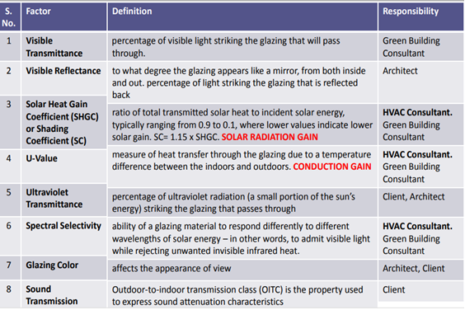

**2.9 SOLAR CELL:**

A solar cell, or photovoltaic cell, is an electrical device that converts the energy of light directly into electricity by the photovoltaic effect, which is a physical and chemical phenomenon. It is a form of photoelectric cell, defined as a device whose electrical characteristics, such as current, voltage, or resistance, vary when exposed to light. Individual solar cell devices can be combined to form modules, otherwise known as solar panels. In basic terms a single junction silicon solar cell can produce a maximum open-circuit voltage of approximately 0.5 to 0.6 volts.

Solar cells are described as being photovoltaic, irrespective of whether the source is sunlight or an artificial light. They are used as a photodetector (for example infrared detectors), detecting light or other electromagnetic radiation near the visible range, or measuring light intensity.

The operation of a photovoltaic (PV) cell requires three basic attributes:

The absorption of light, generating either electron-hole pairs or excitons.

The separation of charge carriers of opposite types.

The separate extraction of those carriers to an external circuit.

In contrast, a solar thermal collector supplies heat by absorbing sunlight, for the purpose of either direct heating or indirect electrical power generation from heat. A "photo electrolytic cell" (photoelectrochemical cell), on the other hand, refers either to a type of photovoltaic cell (like that developed by Edmond Becquerel and modern dye-sensitized solar cells), or to a device that splits water directly into hydrogen and oxygen using only solar illumination.

Solar cells were first used in a prominent application when they were proposed and flown on the Vanguard satellite in 1958, as an alternative power source to the primary battery power source. By adding cells to the outside of the body, the mission time could be extended with no major changes to the spacecraft or its power systems. In 1959 the United States launched Explorer 6, featuring large wing-shaped solar arrays, which became a common feature in satellites. These arrays consisted of 9600 Hoffman solar cells.

By the 1960s, solar cells were (and still are) the main power source for most Earth orbiting satellites and a number of probes into the solar system, since they offered the best power-to-weight ratio. However, this success was possible because in the space application, power system costs could be high, because space users had few other power options, and were willing to pay for the best possible cells. The space power market drove the development of higher efficiencies in solar cells up until the National Science Foundation "Research Applied to National Needs" program began to push development of solar cells for terrestrial applications.

In the early 1990s the technology used for space solar cells diverged from the silicon technology used for terrestrial panels, with the spacecraft application shifting to gallium arsenide-based III-V semiconductor materials, which then evolved into the modern III-V multijunction photovoltaic cell used on spacecraft.

**2.10 Insulating Materials:**

Thermal insulation is the reduction of heat transfer (i.e. the transfer of thermal energy between objects of differing temperature) between objects in thermal contact or in range of radiative influence. Thermal insulation can be achieved with specially engineered methods or processes, as well as with suitable object shapes and materials.

Different Types of Insulating materials are as follow:

**1. Fibre glass:**

Fiberglass is the most common insulation used in modern times. Because of how it is made, by effectively weaving fine strands of glass into an insulation material, fiberglass is able to minimize heat transfer. The main downside of fiberglass is the danger of handling it. Since fiberglass is made out of finely woven silicon, glass powder and tiny shards of glass are formed. These can cause damage to the eyes, lungs, and even skin if the proper safety equipment isn’t worn. Nevertheless, when the proper safety equipment is used, fiberglass installation can be performed without incident. Fiberglass is an excellent non-flammable insulation material, with R-values ranging from R-2.9 to R-3.8 per inch. If you are seeking a cheap insulation this is definitely the way to go, though installing it requires safety precautions. Be sure to use eye protection, masks, and gloves when handling this product.

**2. Mineral Wool:**

Mineral wool actually refers to several different types of insulation. First, it may refer to glass wool which is fiberglass manufactured from recycled glass. Second, it may refer to rock wool which is a type of insulation made from basalt. Finally, it may refer to slag wool which is produced from the slag from steel mills. The majority of mineral wool in the United States is actually slag wool.

Mineral wool can be purchased in batts or as a loose material. Most mineral wool does not have additives to make it fire resistant, making it poor for use in situation where extreme heat is present. However, it is not combustable. When used in conjunction with other, more fire-resistant forms of insulation, mineral wool can definitely be an effective way of insulating large areas. Mineral wool has an R-value ranging from R-2.8 to R-3.5.

**3. Cellulose:**

Cellulose insulation is perhaps one of the eco-friendliest forms of insulation. Cellulose is made from recycled cardboard, paper, and other similar materials and comes in loose form. Cellulose has an R-value between R-3.1 and R-3.7. Some recent studies on cellulose have shown that it might be an excellent product for use in minimizing fire damage. Because of the compactness of the material, cellulose contains next to no oxygen within it. Without oxygen within the material, this helps to minimize the amount of damage that a fire can cause.

So not only is cellulose perhaps one of the eco-friendliest forms of insulation, but it is also one of the most fire-resistant forms of insulation. However, there are certain downsides to this material as well, such as the allergies that some people may have to newspaper dust. Also, finding individuals skilled in using this type of insulation is relatively hard compared to, say, fiberglass. Still, cellulose is a cheap and effective means of insulating.

**4. Polyurethane Foam:**

While not the most abundant of insulations, polyurethane foams are an excellent form of insulation. Nowadays, polyurethane foams use non-chlorofluorocarbon (CFC) gas for use as a blowing agent. This helps to decrease the amount of damage to the ozone layer. They are relatively light, weighing approximately two pounds per cubic foot (2 lb/ft^3). They have an R-value of approximately R-6.3 per inch of thickness. There are also low-density foams that can be sprayed into areas that have no insulation. These types of polyurethane insulation tend to have approximately R-3.6 rating per inch of thickness. Another advantage of this type of insulation is that it is fire resistant.

**5. Polystyrene:**

Polystyrene is a waterproof thermoplastic foam which is an excellent sound and temperature insulation material. It comes in two types, expanded (EPS) and extruded (XEPS) also known as Styrofoam. The two types differ in performance ratings and cost. The more costly XEPS has an R-value of R-5.5 while EPS is R-4. Polystyrene insulation has a uniquely smooth surface which no other type of insulation possesses.

Typically, the foam is created or cut into blocks, ideal for wall insulation. The foam is flammable and needs to be coated in a fireproofing chemical called Hexabromocyclododecane (HBCD). HBCD has been brought under fire recently for health and environmental risks associated with its use.

Other Common Insulation Materials.

Although the items listed above are the most common insulation materials, they are not the only ones used. Recently, materials like aerogel (used by NASA for the construction of heat resistant tiles, capable of withstanding heat up to approximately 2000 degrees Fahrenheit with little or no heat transfer), have become affordable and available. One in particular is Pyrogel XT. Pyrogel is one of the most efficient industrial insulations in the world. Its required thicknesses are 50% – 80% less than other insulation materials. Although a little more expensive than some of the other insulation materials, Pyrogel is being used more and more for specific applications.

Other insulation materials not mentioned are natural fibres such as hemp, sheep’s wool, cotton, and straw. Polyisocyanurate, similar to polyurethane, is a closed cell thermoset plastic with a high R-value making it a popular choice as an insulator as well. Some health hazardous materials that were used in the past as insulation and are now outlawed, unavailable, or uncommonly used are vermiculite, perlite, and urea-formaldehyde. These materials have reputations for containing formaldehyde or asbestos, which has essentially removed them from the list of commonly used insulation materials.

There are many forms of insulation available, each with their own set of properties. Only by researching each kind thoroughly can you discover which will be the right kind for your particular needs. As a quick overview:

Aerogel is more expensive, but definitely the best type of insulation.

Fiberglass is cheap, but requires careful handling.

Mineral wool is effective, but not fire resistant.

Cellulose is fire resistant, eco-friendly, and effective, but hard to apply.

Polyurethane is an all-around good insulation product, though not particularly eco-friendly.

Polystyrene is a diverse insulation material, but its safety is debated.

Table 2.4: Comparison of Glass Material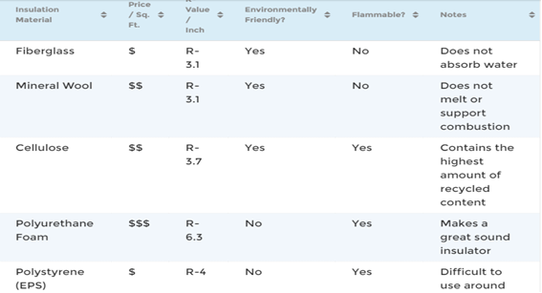al.

**2.11 Chillers and its Types:**

Chillers are machines used to generate cold or chilled water which is distributed around buildings to provide air conditioning. They are also used in some industrial processes but we’re going to primarily focus on their application in air conditioning of buildings typically with Air Handling Units and Fan Coil Units

The first way to categorise a chiller is by defining whether it is a vapor compression or vapor absorption type chiller.

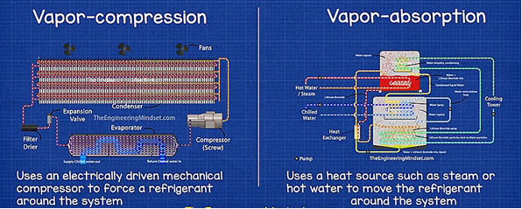

Fig 2.1: Vapour Compression and Vapour Absorption Chiller

Vapor absorption chillers will use a heat source to move the refrigerant around the system rather than using a mechanical compressor. The refrigerant in these chillers move around between areas of different temperature and pressure.

Vapour compression chillers use an electrically driven mechanical compressor to force a refrigerant around the system. These are the most common types of chillers. There are two sub categories for vapor compression chillers which are water cooled or air-cooled chillers

The working principle for both air cooled and water-cooled chillers is the same. A compressor pushes a refrigerant round the inside of the chiller between the condenser, expansion valve, evaporator and back to the compressor. The only difference is that with an air-cooled chiller, fans force air across the exposed tubes of the condenser which carry the heat away. Water cooled chillers have a sealed condenser and water is pumped through to take the heat away and disperse this through the cooling tower. The cooling tower will also use a fan to reject the heat.

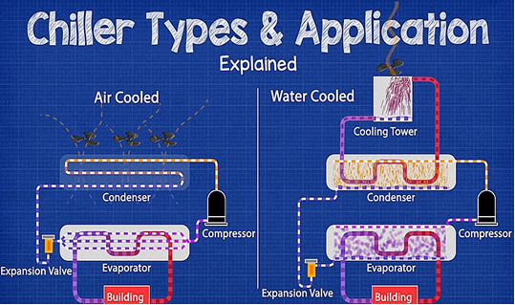

Fig no.2.2: air cooled and water-cooled chiller

Large buildings with cooling loads in excess of 400 tons of refrigeration or 1,400 kW typically use water cooled chillers with either centrifugal compressors or Turbocor compressors within the central plant cooling system. They might also use a separate smaller air-cooled chiller to handle the critical cooling loads such as computer and communication rooms. There might also be an absorption chiller within the central plant system, making use of waste heat, for example from a CHP engine, but these are mostly used alongside mechanical chillers.

Medium sized buildings with a cooling load of around 200 – 400 tons of refrigeration or 700 – 1,400 kW will typically use screw compressors or Turbocor compressors, these can be either water or air cooled, we’ll look at why that would be just shortly. These buildings might also use an absorption chiller if enough high-quality heat is available

Small building with cooling loads under 200 tons or 700 kW will typically use scroll compressors and are typically of air-cooled design. Again, we’ll look at why just shortly, they might also use a different system such as VRF units but this depends on the size of the building and the cooling load.

Absorption chillers should only be used where there is an abundance of high-quality waste heat or cheap heat. They are often found in hospitals and buildings with heated swimming pools. If a commercial office type building uses a combined heat and power (CHP) engine these are often coupled with an absorption chiller which uses the waste heat from the combustion, but in this scenario, these are mostly used in conjunction with electrically driven chillers. Sometimes they are used during times of day when electricity prices peak.

If you have a building with a medium to large cooling load then its recommended that you do not use only one oversized chiller to handle the entire cooling load. This is not efficient and if it fails you will have no cooling capability left.

Instead you should use multiple chillers, in parallel, of different sizes to meet the changing seasonal load at optimal performance with redundancy built in. For example, you have a building with a cooling load of 2,200 Tons, then you should use combinations such as two 1,200-ton chillers or two 900 tones and a 500 ton or a 1,000 ton and two 700-ton chillers etc. The configuration options are almost limitless.

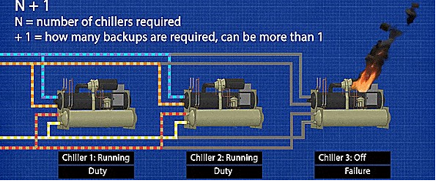 You also need to consider the criticality of the building and the redundancy required, known as N+1, where by “N” is the number of chillers you need and the “+1” or “+2” or “+3” etc is the number of backup chillers needed to continue to meet cooling capacity in the event of a failure.

Fig 2.3: water-cooled chillers.

Water cooled chillers are more efficient, especially for large cooling loads, they use the evaporation of water to dissipate heat which is less energy intensive than blowing air across a hot surface like air cooled chillers. Water also has a higher heat capacity than air so its inherently easier to remove the heat

Water cooled chillers can handle larger loads, for their floor space, compared to air cooled.

Water cooled chillers generally last longer because they are inside the building so deteriorate much slower

These use cooling towers and for this you need access to a constant clean water supply. If the chiller is going to be installed in an area with water restrictions then you don’t want this type.

Water cooled chillers are located within the building and are very large machines, so depending on the compressor technology used, they can create a lot of noise and vibration inside the building which is why they are usually located in the basement.

Water cooled chillers cost more to install and maintain.

Water cooled chillers take up space within the building, they need mechanical plant rooms, more risers, more pumps, cooling towers and water treatment, this space therefore can’t be used for business purposes.

Air cooled chillers

Air cooled chillers cost less to install because they have less equipment.

Air cooled chillers require less space, they can sit on the roof and do not need a mechanical room. This means more space within the building for business purposes.

Air cooled chillers require less maintenance compared to water cooled chillers, again because they have less equipment

Air cooled chiller systems are much simpler design and do not need another set of pumps for the condenser

Air cooled chillers sit outside the building, their fans and compressors will create noise which the surrounding areas might be able to hear, although some measures can be implemented to reduce this

Air cooled chillers typically do not have as long a service life as water cooled chillers because they are exposed to the sun, rain, frost, snow and wind which deteriorate the materials.

Air cooled chillers can suffer from damage, blockages and re-circulation issues.

Unfortunately many building owners want the cheapest upfront option, but this is a bad idea because for a little extra they could have bought a more efficient chiller which will be cheaper to operate especially as chillers can last for around 15 – 25+ years in operation, so it will have paid for itself multiple times and would have resulted in reduced environmental emissions.

**1)Centrifugal chiller**

Fig 2.4: Centrifugal chillers.

Water cooled chiller and it is used in medium to large cooling loads

Typically, available in 150 – 6,000 TR, 530 – 21,000 kW

Water cooled COP of between 5.8 to 7.1.

Typically use only one compressor sometimes two for exceptionally large capacity Work best at full loading, VFD can be fitted to improve part load

Use one or two rotating impellors to compress the refrigerant and force it around the chiller Capacity control through speed control and vane guides

**2) Turbocor chillers:**

Fig 2.5: turbocor chiller.

Air or water-cooled chillers

Used in all cooling loads from large to small buildings

Typically, available in 60 – 1500 TR, 210 – 5,200 kW

COP of 4.6 up to 10.

One or more compressors used, staged and speed varied

Variable speed controller, soft starter, magnetic bearings, only one moving part, oil free

Use two rotating impellors to compress the refrigerant

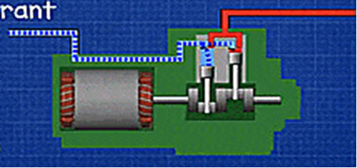**3) Reciprocating chillers:**

Fig 2.6: reciprocating chillers.

Air- or water-cooled chillers – old technology, less common now

Used in small to medium cooling loads – common in simple low-cost refrigerators

Typically, available in 50 – 500 TR, 170 – 1,700 kW

COP of 4.2 to 5.5

Use a piston and chamber to compress refrigerant

Capacity control through compressor staging or cylinder unloading and speed control

**4) Scroll chiller:**

Fig 2.7: scroll chiller.

Air or water-cooled chillers

Used in small to medium cooling loads

Typically, available 40 – 400 TR, 140 – 1,400 kW

Air cooled COP 3.2 – 4.86 Water cooled COP 4.45 – 6.2

One or more compressors, fixed or variable speed, staged or speed controlled

Use two spiral plates to compress the refrigerant, one fixed in place, one rotates.

Capacity controlled via momentarily separating scrolls with solenoid valve and electronic modulation.

**5) Screw chiller:**

Fig 2.8: screw chillers.

Air or water-cooled chillers

Used in small to medium cooling loads

Typically, 70 – 600 TR, 250 – 2,100 kW

Air cooled COP 2.9 – 4.15 Water cooled COP: 4.7 – 6.07

Typically, 1 compressor on water cooled, 1 or 2 compressors on air cooled

Uses two interlocking rotating helical rotors to compress the refrigerant, capacity is controlled via speed control or slider

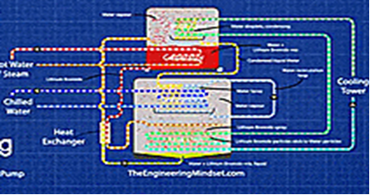**6) Absorption chillers:**

Fig 2.9: absorption chillers.

Use heat to drive the refrigeration process, usually steam or hot water

Used in Medium to large buildings, Hospitals, Swimming centres, Heat Networks

Typically, 70 – 1,400 TR, 250 – 4,900 kW

COP of approx. 0.6 to 1.9

No compressor, direct or indirect fired. Capacity controlled via amount of heat entering

Idea for using waste heat or cheap heat, sometimes used to offset peak electricity costs

Typically combined with mechanical chillers.

**2.12: ADIABATIC COOLING KIT:**

Adiabatic cooling system is the process of reducing heat energy with the help of conventional natural methods like sprinkling of water to maintain the temperature.

Adiabatic cooling system is designed for an Econet system especially for the use in the greenhouses of nurseries or the farms to protect the plants from excess of sunlight. It is one of the energies saving product which works on the process of adiabatic cooling. It uses water sprinkler for temperature control with the help of sensor and PLC based controller.

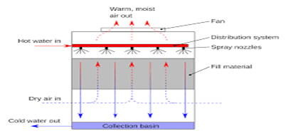

Fig 2.10: adiabatic cooling kit

In adiabatic cooling system the water sprays are connected in series to provide adiabatic cooling to the incoming air stream it is been initiated via ambient sensor or through refrigeration head pressure override. As the temperature exceeds beyond its limits the Econet controller initiates water spray to reduce the overall temperature for the condenser which will ultimately reduce the condensing pressure to save the energy required to maintain the system temperature at the time of high ambient periods.

The adiabatic cooling system provides best temperature control with following advantages:

In adiabatic cooling system Temperature control is carried out without human interactions. Conserves more energy as compared to conventional systems. Adiabatic cooling system is Very economic and user friendly device

Automotive temperature control of greenhouses is possible by adiabatic cooling process without human interaction.

In adiabatic cooling system Econet has been fitted to units worldwide where its licensed water splash innovation has gone with numerous organizations to lessen their vitality power with insignificant endeavours. The framework once fitted is essentially support free.

Econet uses the age-old adiabatic cooling principle and a ‘ambient controller’ to reduce the temperature of air before it is drawn into the heat rejection coil of an air conditioner, reducing the temperature at input to lower energy costs.

It offers you the best pre-cooling. With electricity costs on the rise, investment in an Econet System will have a quick payback period – less than one cooling season.

In adiabatic cooling system water consumption is minimized as the spray is intermittent and only activated when required, hence it consumes up to 79% less water than any other wet system. With no reservoir and a large droplet size, there is no chemical treatment required and no health risks.

It can be reconstructed to make any size and shape of air conditioning and refrigeration unit, (mini split, air-cooled chiller, rooftop unit) without affecting warranty.

Adiabatic cooling system is Highly cost effective, the system is easy to install, and is sold as a kit to suit the application.

**2.13: Thermo active building systems in Japanese climate:**

Thermo active building systems (TABS) have been applied in office buildings as a promising energy efficient solution in many European countries. The utilization of building thermal mass helps to provide high quality thermal environments with less energy consumption. However, the concept of TABS is entirely new in Japan. This paper introduces and evaluates TABS under Tokyo weather conditions to clarify the potential of use TABS in Japan.

Cooling capacity of thermo active building systems used in an office building was evaluated by means of dynamic simulations. Two central rooms of the office were selected for the analysis. Six water control strategies were studied and two of those were found reasonable and suitable for TABS use in Tokyo.

These two strategies are: free-cooling using underground heat exchanger combined with TABS and free-cooling with desiccant dehumidification system. For these two cases, the operative temperature was between 22-27ºC during 97~99% of the occupation time. The operative temperature drift was less than 4ºC per day. The pump running time was 7 hours per day and the cooling power of the TABS was 36 W/m2 floor area. For those free-cooling cases, the average supply water temperature was 20ºC, which shows that free-cooling is achievable using underground heat exchangers even considering the temperature increase of the ground during cooling season.

Thermo active building systems (TABS) are water-based heating/cooling systems in which pipes are embedded in concrete slabs of buildings. A prominent advantage of TABS is to reduce the peak load by activating the thermal storage capacity of the concrete slabs. The use of TABS started in the early 1990s in Switzerland. In 2005 a series of European standards were provided for calculating design heating/cooling capacity under steady-state conditions of TABS, dimensioning and installation and system design based on simple calculations with regards to temperature drift during the occupancy time. An ISO standard was published in 2012 for dimensioning and calculation of dynamic heating and cooling capacity for TABS.

The reduction of peak load leads to several advantages, for example, reduced investment for the cooling equipment and reduced cost of installation. Rijksen et al. performed on-site measurements and obtained the required cooling power of a building equipped with TABS. It was found that by using TABS the chiller capacity could be reduced by up to 50% compare to air-conditioning systems. An investigation on building thermal mass control showed that cost-optimal control could achieve total cost reductions of up to 13%. A TABS combined with a packaged air conditioning system in residential buildings was simulated by Park et al. It was found that TABS decreased both the heat source energy consumption and the terminal energy use, especially for low-thermal-load buildings.[5]

However, in Japan it is still an entirely new concept. The possibility of using TABS in Japan is discussed in this paper with dynamic simulations of TABS under Tokyo weather conditions. Building simulation model.

The cooling performance and thermal comfort of an office building equipped with TABS are simulated with the dynamical simulation program TRNSYS. Water pipes are embedded in the slabs on all the floors. A central room module in the building with offices on both side of a corridor is selected. The chosen model is based on research by Olesen et al. The floor area of each office is 19.8 m2 and the water flow rate of the TABS at each office is 350 kg/h. Simulations are done for the cooling season in Tokyo. Table 2 shows the outdoor design conditions

TABS coupled with a constant air volume (CAV) ventilation system are used in the offices. TABS is switched on during night time between 18:00 and 6:00 from Sunday night till Thursday night and operating while room operative temperature exceeds 23ºC. The CAV system operates during office TABS coupled with a constant air volume (CAV) ventilation system are used in the offices. TABS is switched on during night time between 18:00 and 6:00 from Sunday night till Thursday night and operating while room operative temperature exceeds 23ºC. The CAV system operates during office hours from 8:00-12:00 and from 13:00-17:00 on workdays with an air change rate of 1.3 h. The supply air temperature is 20ºC and the humidity is 40%. Infiltration is constant at 0.2 h. [6]

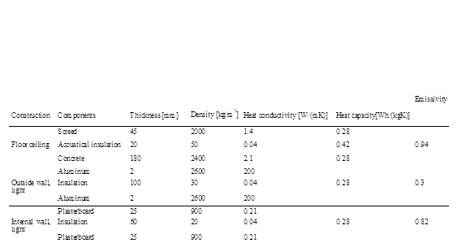Table 2.5: Component properties of the building, duced from Kolariket a reprol

Heat transfer coefficient = 2.1 W/(m2K)

Heat transfer coefficient = 1.1 W/(m2K)

Solar heat gain coefficient = 0.58

Previous research shows that the cooling of building can be managed with TABS if the peak loads are less than 50 W/m2 [7]. In this building model, internal heat load of each office during occupied periods is assumed to be 550 W, which corresponds to 27.8 W/m2; during lunch break (from 12:00-13:00) it is assumed to be 350 W. The windows in the offices are equipped with solar shading device. When the window receives direct radiation, the total shading coefficient of the window is set to 0.5 by using external blinds.

In addition, free-cooling is considered using underground heat exchanger combined with TABS. The supply water temperature is set as 18ºC as the mean annual ground temperature is 17 ºC in Tokyo. The temperature is also limited to the room dew point temperature. Furthermore, desiccant dehumidification system and radiant cooling system is a common combination in Japan as a novel system for low energy buildings. The supply air temperature and humidity of desiccant dehumidifier is commonly 25ºC and 40%. For this scheme, two adaptive control strategies are considered: free-cooling (FC) and free-cooling combined with desiccant dehumidifier systems (FCD).

2962.

FC: Tsup = max (18, Tdew). For free-cooling combined with desiccant dehumidifier systems, some calculation conditions are adjusted as following. FCD: Tsup = max (18, Tdew), Supply air temperature of desiccant = 25ºC, Operation pump during daytime when to! 26.5qC. [7]

The comfort is evaluated by the hourly mean room operative temperature for the time of occupancy, which is Monday-Friday, from 8:00 to 17:00. The maximum operative temperature allowed for comfort conditions in Tokyo is taken to be 27ºC. The calculated operative temperatures will be compared to the comfort range 22~27ºC, which is given for summer (cooling season) in category C buildings by the standard of ISO 7730 [9]. Furthermore, the evaluation of the results is conducted by means of the cooling season thermal rejection, pump running time, daily thermal rejection.

The operative temperature interval during the occupation. The operative temperature for all the cases is within the range of 22~27ºC during more than 93% of occupation time. The operative temperature drift during occupation is within 4ºC for all the cases (shown in Figure 3), which means that the comfort temperature range based on steady-state conditions in ISO 7730 is met [12].

Table 3 shows cooling power of the TABS for all the cases carried out under the weather conditions in Tokyo. The mean pump running hours per day are significantly different among the cases. The longer time means more energy consumption by the pumps. Pump running time for C2 and C3 exceed 10 hours because the supply water temperatures for these cases are higher compared with other cases. Conversely, the water temperature for C4 is low which leads to a short pump running time. However, the water temperature for C4 is even lower than the dew point temperature of the room during most time of the operation which will result in condensation. Thus, C1 is considered the best strategy for water temperature control among C1~C4.

The two adaptive control algorithms of free-cooling (FC) and free-cooling combined with desiccant dehumidifier (FCD) shows similar performance as C1. For these three cases, mean operative temperature during occupation is 24.5ºC, mean thermal rejection by the TABS is between 313~319 Wh/(m2day) and mean cooling power is 36 W/m2 floor area. Although the pump running energy consumption for C1 would be higher because chillers are necessary for C1~C4. The energy consumption of chillers is usually 3~4 times as much as for the pumps. The pump running time for FCD is 38-hour more than FC, which is due to pump operating during daytime.[10]

Supply water temperature for C1, FC and FCD cases during the cooling season is shown in Figure 4. The supply water temperature for C1 is the room dew point temperature, which vary between 11 and 24ºC. The wide range of the temperature makes this control strategy unpractical. For the whole cooling season, the supply water temperature for FC and FCD cases is from 18 to 24ºC, which matches practical supply water temperature of ground heat exchangers in summer in Tokyo. In most time of June and July the dew point temperature is lower than 18me for FC and FCD is about 1 h/day longer than that for C1, the total enºC, which is the assumed supply water temperature by ground heat exchangers. In August and September, the supply water temperature is mostly higher than 18ºC and up to 24ºC.[11]

The operative temperature for FCD case is less than 27ºC due to the TABS being operated during daytime when the operative temperature is higher than 26.5ºC. In daytime the room dew point temperature is far lower than 18ºC, thus the TABS operated with the supply water temperature of 18ºC. For FC and FCD the supply water temperature was mostly higher than 18ºC, which shows that free-cooling is achievable by using underground heat exchangers even when considering the temperature increase of the ground during cooling season.

Office rooms equipped with TABS were simulated under Tokyo weather conditions. Each office has an internal heat gain of 27.8 W/m2 floor area and 30% glass in the west or east façade. The TABS was activated during night in order to evaluate the performance for peak loads reduction. Two water control strategies were found reasonable and suitable for TABS use in Tokyo: FC, free-cooling using underground heat exchanger combined with TABS and FCD, free-cooling with desiccant dehumidification system. For these two cases, the operative temperature was between 22-27ºC during 97~99% of the occupation time. The operative temperature drift was less than 4ºC per day. The pump running time was about 7 h/day and the cooling power of the TABS was 36 W/m2 floor area. For the cases of FC and FCD, the supply water temperature was between 18 and 24ºC, which is higher than the mean annual ground temperature of 17ºC. This indicates that free-cooling is achievable by using underground heat exchangers even considering the temperature increase of the ground during cooling season.[12]

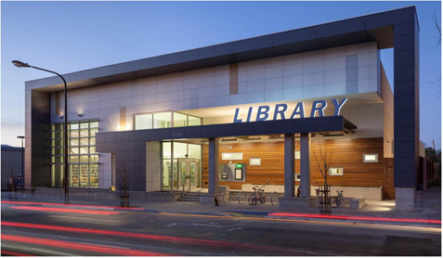 **2.14 Zero Net Energy Building at WEST BERKELEY PUBLIC LIBRARY:**

Fig 2.11: west Berkeley public library

**2.14.1 OVERVIEW:**

Building Size: 9,400 SF

Location: Berkeley, CA

Construction Type: New Construction

Completion Date: December 2013

Building Type: Public Assembly

CA Climate Zone: 3

Energy Use: Electric

Construction Cost: $5.5 Million

The West Berkeley Public Library is the first verified zero net energy (ZNE) public library in California. Completed in late 2013, the 9,400-square-foot library produces as much or more energy than it consumes on an annual basis. To reach its zero net energy goals, designers used a variety of innovative technologies and passive strategies. To ensure the proper integration of all the systems, the project’s design team partnered with Pacific Gas & Electric (PG&E) to access resources from the state-wide Savings by Design program that provided funding for simulations which were key to the design’s success. The library is also one of the first projects to take part in the PG&E ZNE Pilot Program.

**2.14.2 Planning & Design Approach:** The design of the library fully embraces both passive strategies and a “high tech” approach to building operation. The control system integrates the electric and thermal solar energy generation with the demand control ventilation, radiant heating and cooling, and lighting systems. The suite of modelling work included: climate, solar, daylighting, energy, and computational fluid dynamics. To offset the energy consumption, solar photovoltaics and solar thermal collection systems cover the roof of the building, along with a series of interspersed skylights.

The complexity of the building was well designed and executed, and the result is a net-positive, energy-producing building.

**Financing:**

The project is the first publicly funded ZNE library in California. With a $5.5 million construction cost (including all change orders), the cost per square foot is comparable to that of similar library buildings in the same area that were built in the same time period but without the zero net energy performance attribute.

The additional incremental costs of $43,000 for modelling work to properly design the natural ventilation, solar renewable system, and other complexities were completely offset by a grant from the PG&E Savings by Design program. The project also received a standard Savings by Design incentive that went directly to the owner.

**2.14.3 Energy Efficiency Strategies and Features:**

**Lighting and Daylighting:**

The library takes full advantage of the natural sunlight with a series of skylights and a large glass facade designed to eliminate the need for artificial lighting during the day. Given the operating hours of the library, this reduces lighting energy to near zero. Electrical lighting is tied to daylight sensors, which is used to supplement the daylight on cloudy or darker days.

**Envelope:**

The library envelope provides excellent thermal and acoustic insulation, maximizing energy performance and comfort for occupants. A triple-paned, store-front glazing system along noisy University Avenue helps manage acoustic performance. The vestibule at the entrance maintains pressurization in the building, and prevents warm or cool air from escaping. The envelope also included a cool roof with an R40 insulation value, R31 walls when considering the thermal bridging at the microlam studs. Further, the building was built on a 12” structural slab, with a single layer of rigid insulation between the 4” radiant slap and the 18” mat slap. All conduit was run beneath the mat slab.

where patrons and staff can easily use them. Automatically controlled windows are located high in the space and have preheating hydronic convectors at the openings to prevent cold drafts caused by cold air entering the space in winter.

**2.14.4 Renewable Energy Generation and Storage:**

Designing the solar panel configuration was one of the great challenges for this project. Given the tight urban density and nearby buildings shading the library, the design team used extensive modelling to optimize the solar design for the site,

all while incorporating skylights to nearly eliminate the lighting loads. The project includes four photovoltaic (PV) arrays arranged between three rows of skylights, for a total of 120 panels. The library also has 16 solar thermal panels, which are arranged into two arrays in the northeast corner of the roof. New Buildings Institute (NBI) has evaluated the library’s 2014 calendar year’s performance and verified that the library is a zero-energy building, with renewable energy production of 27.6 kBtu/SF/yr., and consumption of only 24.7 kBtu/SF/yr. With a small amount of overproduction, the project has achieved a verified net positive energy performance.

**2.14.5 Post Occupancy:**

The project process included both LEED-enhanced commissioning and ZNE commissioning to ensure the basis of design was met. Commissioning staff participated throughout the process from monthly meetings early in the design phase and into construction, then weekly meetings were needed as mechanical systems were being installed. Further involvement of the commissioning agent included training of staff and operators at occupancy and then continued tweaking and tuning to ensure systems were properly operating.

**2.14.6 Monitoring:**

In order to track and maintain the performance of the building, the energy consumption and generation are logged in the building management system. This allows the building operators to continuously monitor the building systems, tracking progress towards the goal of reaching net zero energy.

The building has an energy dashboard at the entrance which shows the sustainable design features and current energy balance of the electrical loads and PV generation. Keeping the energy use of the building visible to staff and occupants helps raise awareness of energy consumption, which in turn leads to lower occupant-driven energy loads, such as plug loads. Library staff have educational materials to help inform both staff and public understanding of the building and staff routinely host public tours about the building’s design and operation.[13]

**CHAPTER: 03**

**DESIGN AND CALCULATIONS**

**3.1 Conventional Design of HVAC System:**

The project deals with designing an HVAC system for a site at Nagpur considering all the climate conditions and factors according to standard procedures.

The Intelligent HVAC System will control Heating, Ventilation and Air Conditioning (HVAC) of the Building Structure with 6 Floor, Basement and Terrace and having 2 wings. The project also consists of Full height atrium in between the wings, 4 stair cases and 8 Offices on each floor.

Studies regarding heat loads and various installation equipment, along with glass study were put together into this project considering the economic advantage of client as well as the safety of the occupants.

**3.2 Glass selection:**

**1) Single glazed glass**

A single glazed window is constr0ucted using a single plane of glass.

Range: 3 – 10 mm

Efficiency: 20 times less than Double-glazing.

**2) Double glazed glass**

Good sound dampening quality

Reduces heat and UV entry

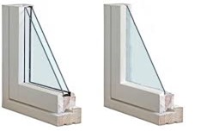Provides good light and reduces outward heat loss

Fig3.1: singled doubled glazed glass.

**GLASS RECOMMENDATIONS:**

Double glazed glass

Outside glass as low e glass.

Inside glass as laminated glass.

Argon layer in between for better acoustics.

Pristine white-code PLTT, transmission 74%, SHGC 0.54

**ADVANTAGES:**

1) Reduce dew formation.

2) Reduce sound transmission.

3) Provides more visible light.

4) High strength.

**3.3 Heat Load Assumptions:**

While calculating heat load summer conditions were considered and corresponding values were selected from ISHRAE handbook.

1.Considering may as the month of design.

2.Considering 4:00 pm as the time of day.

3.Considering double vertical glass with u factor 0.55 btu/hr sqft

4.Ups load is taken as 20% of the computer load.

5.Considering one coffee maker and one water cooler in each office.

6.4th floor is not air conditioned but is ventilated by open windows and fans as it is the refugee area.

7.Psychometric charts were used for calculating all temperatures

8.Bypass factor is taken as 0.1.

9.Infiltrations are not considered for offices but considered for atrium area.

10.All the calculations are done with respect to ISHRAE standard codes.

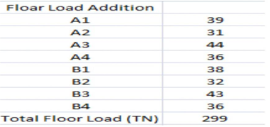Table 3.1: heat load for single floor.

**Floor layout:**

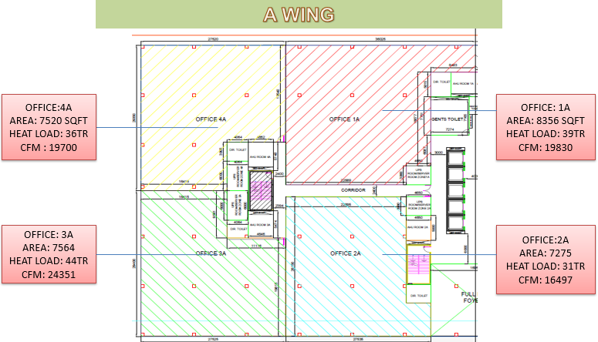

Fig 3.2: Floor Layout A Wing

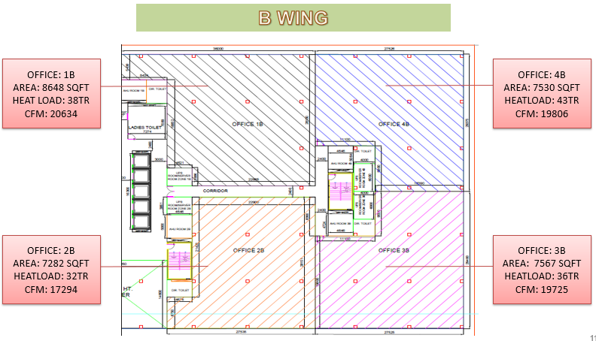

Fig 3.3: Floor Layout B Wing

**Total heat load:**

|  |  |  |  |  |  |
| --- | --- | --- | --- | --- | --- |
| Rooms | G+1+2 | 3 | 5 | 6 | Total load |
| Load | 904 | 394 | 394 | 434 | 2126 |

|  |  |  |  |  |  |
| --- | --- | --- | --- | --- | --- |
| Atrium | Gr | 1+2 | 3+5 | 6 | Total load |
| Load | 26 | 71.5 | - | 16.5 | 114 |

|  |  |  |  |
| --- | --- | --- | --- |
| Corridor | 1+2 | Gr+3+5+6 | Total load |
| Load | 27 | 67 | 94 |

|  |  |  |  |
| --- | --- | --- | --- |
| Rooms | Load per ups system | No of ups systems | Total load |
| G+1+2+3+5+6 | 4 | 48 | 192 |
| Total load = 192TR | | | |

**3.4 Cooling unit selection:**

* Points which are taken in consideration
* Climatic Condition
* Amount of water available
* Flexibility of Installment and Operation
* Power consumed
* Maintenance
* Life cycle

Cooling unit selected is **chiller.**

**3.5 Non-Conventional Design:**

In this design various non-conventional as well as innovative techniques are used such as new

Glass film, TABS, FPC etc.

The includes the following

**3.6 Glass selection:**

It would be advantageous to reduce the energy consumption of building to a more environmentally friendly level and to a more energy cost efficient level by using Solar Control Window Film (SCWF). These films help to keep the summer heat out and help to lock the heat inside in winter.

The summer period in Nagpur is about 4 months long starting from February till May with the hottest period from mid-April till end of May. Similarly, winter period is also for around 4 months starting from October till January with the coldest period from mid-December till mid-January.

In this part we will be calculating the Solar Gain coefficient, the net annual cost saving due to sticking SCWF on the window and simple payback period.

In conventional method we use normal glass with SHGC value of 0.76, But in our hybrid technique we use a film which gives the SHGC value of 0.26. that means the difference becomes 0.5. the effect of that change is very significant in terms of efficiency, savings, payback period

**KEYWORD:**

1. SOLAR HAET GAIN COEFFICIENT (SHGC): It is the ratio of solar heat transmitted to the total incident solar energy.
2. VISIBLE TRANSMITTANCE: Percentage of visible light striking the glass that will pass through.
3. SPECTRAL SELECTIVITY: Ability of glazing to respond differently to different wavelength of solar energy.
4. SOLAR GAIN: Solar gain (also known as solar heat gain or passive solar gain) refers to the increase in thermal energy of a space, object or structure as it absorbs incident solar radiation.

**ABOUT SOLAR CONTROL WINDOW FILM (SCWF)**

These films are design to absorb or reflect the incident solar radiations, in order to diminish solar heat gain through the glass. SCWF is a micro thin film made of polyester and metalized coating bonded by adhesive that is install on the glass surface to provide significant solar protection. It screens out the solar heat i.e. cuts downs the sun`s heat while letting the maximum amount of natural light. It also screens out harmful Ultra Violet (U.V) rays and uncomfortable glare. It also reduces the hazard of broken glass by keeping the pieces together and safely attach to the film.

**SPECIFICATION OF GLASSES USED:**

* The actual glass used

insulated DGU with SHGC VALUE= 0.76.

* The new glass with film which is to be proposed

SCWF (Solar Control window film) with SHGC VALUE= 0.26

4mm thick clear window glass.

**CALCULATION:**

PROCEDURE:

* Calculate the total solar heat flux incident on the glazing during summer and winter months.
* Then cooling load decrease and heating load increase are determined.
* After that decrease in cooling cost and increase in heating cos are calculated.
* After that cost saving is determined.

**STEP 1:**

Q (solar summer) = sum of {H(month)*no. of days in that month}

= 806.96 KWH/yr.

Q (solar winter) = sum of {H(month)*no. of days in that month}

= 629.14 KWH/yr.

Where H(month) = Average monthly solar radiation

**Average Direct Normal Irradiance Average Global Horizontal Irradiance**

| **Monthly Average** | |
| --- | --- |
| JAN | 6.17 |
| FEB | 6.96 |
| MAR | 6.69 |
| APR | 6.71 |
| MAY | 6.64 |
| JUN | 3.86 |
| JUL | 2.60 |
| AUG | 2.23 |
| SEP | 4.65 |
| OCT | 6.30 |
| NOV | 6.46 |
| DEC | 6.51 |

| **Monthly Average** | |
| --- | --- |
| JAN | 4.92 |
| FEB | 5.87 |
| MAR | 6.58 |
| APR | 7.16 |
| MAY | 7.22 |
| JUN | 5.61 |
| JUL | 4.84 |
| AUG | 4.36 |
| SEP | 5.43 |
| OCT | 5.64 |
| NOV | 5.12 |
| DEC | 4.78 |

(Latitude: 21.15   Longitude: 79.05)

**Step 2:**

Area of wall 1: A1 = 125.45 m2 = 1350.33 sqft

Area of wall 2: A2 = 117.70 m2 = 1266.91 sqft

For Wall 1:

Cooling load decrease = Q (solar summer) *change in SHGC * Area of glazing

= 50616.56 KWH/yr.

Heating load increase = Q (solar winter) * change in SHGC * Area of glazing

= 39462.81 KWH/yr.

For WALL 2:

Cooling load decrease = Q (solar summer) * change in SHGC * Area of glazing

= 47489.59 KWH/yr.

Heating load increase = Q (solar winter) * change in SHGC * Area of glazing

= 37024.88 KWH/yr.

**Step 3:**

As on 15th October 2018 unit cost of fuel = 1.16$ =85.33 Rs

Assuming Efficiency =0.8 and COP=2.5

Unit cost of electricity (for 100 units and above in Nagpur) = 12.8 Rs

For glass 1

increase in heating cost = heating load * unit cost of fuel/efficiency

=143609.32 Rs/yr.

decrease in cooling cost = cooling load * unit cost of electricity/COP

= 259156.787 Rs/yr.

annual cost saving = **115547.47 Rs/yr.**

For glass 2

increase in heating cost = heating load * unit cost of fuel/efficiency

=134738.20 Rs/yr.

decrease in cooling cost = cooling load * unit cost of electricity/COP

= 243146.73 Rs/yr.

annual cost saving = **108408.53 Rs/yr.**

**Step 4:**

Total implementation cost = 450* total area in sqft = **1177758 Rs**

(considering cost of installation per sqft of glass panel =450rs)

Payback period = **5.26 yr.**

**3.7 TABS:**

**Thermal conductivities:**

PEX = 0.4 w (K2)

PEX with CNT = 0.81 w/mk

Sound = 2.5 w/mk (k1)

Q = K A Δ T

q = ΔT / R

Δ= 2000*600 mm2

= 2*0.6

=1.2 m2

L = 12.87 m, r2 = 5mm, r1= 3.7mm

R2 = ln (5/3.7) / 2π*0.41*12.87

= 9.082 * 10-3 w/mk

R1 = l / kA1

= 0.025/1.2*25

=0.833*10-3 w/mk

q = ΔT / R

Reff = 9.915 * 10-3 w/mk

FOR OFFICE: 4B

=2000 * 600

l = 1800 * 4 + 150 * 2

= 7500

Total length = (πd /2) * 3

= 3 * π * 100

= 9425 mm

Total length = 8442.5 mm

= 8.44 m

A = 1.2 m2

R2 = ln (5/3.7) / 2π*0.41*8.44

=0.014

K1 = 2.7 w/mk

R1 = 0.025/2.7*1.2 =l1 / k1A1

R1 = 7.716 * 10-3

R2 = 0.014

Reff = 0.0271 k/w

Q = ΔT / R = 25-19/0.0217 = 276.49 w

Q (per module) * no. of modules = 570 * 276.49

= 157599.3 w

= 157.6 kw

Qreq = 150.5 kw

FOR OFFICE: 4B

FOR 1800 * 600

l = 1600*4 + 150*2

= 6700

Total length = (πd * 3) /2

= 942.5 mm

Total length = 942.5 + 6700

= 7642.5

= 7.64 m

A = 1.8 * 0.6 = 1.08

R2 = ln (5.0/3.7) / 2π*0.41*7.64 = 0.0153

R1 = 0.025/2.7*1.28 = 8.573 * 10-3

Reff = 0.0239 k/w

ΔT = 6

Q = 28 -19 / 0.0239 = 251.04 w

Q(module) * no. of module = 251 * 510

= 143092.8

= 143.09 kw

Thus, ΔT = 7 i.e. Tin = 18

Q = 25-18/ 0.0239 = 292.9 w

QΔT=? = 292.9

Q = 292.9 * 870

Q = 166.953 kw

For 1800 * 600

Q = mCPΔT

261.04 = mCPΔT

281.04 = m*4.18*10-3*(28-19)

m = 0.01 kg/s

ΔAV = 0.01

A = 0.01 / ΔA

= 0.01/103*43*10-6

=0.233 m/s

= 23.26 cm/s

Area = 8.2137 * 109 – 967.694*106 – 128.619*105

= 7117.33 m2

Flow velocity 2.5 m/s

Flow rate = 1.075*10-4 m/s

= 0.1075 kg/s

Q = mCp(ΔT)

= 0.1075 * 4.187(25-19)

= 2.7 kw

276.49 = mCP(ΔT)

276.49 = m*4.18*6

m = 11 g/s

= 11*10-3 kg/s

V = 11*10-6 m3/s

do = 10

di = 7.4 mm

A = T/4 * di2 = 43 mm2 = 43*10-6m2

Inlet velocity:

For 2000*600

Q = mCP(ΔT)

276.49 = m*4.18*103*(25-19) [Ti = 19, To= 25]

m = 0.01102 kg/s [ A = 43*10-6 m2, Δ= 103 kg/m3]

ΔAV = 0.01102

V = 0.01102/103*43*10-6

= 0.256 m/s

= 25.6 cm/s

For 2000 * 600:

Q = mCP(ΔT)

276.49 = m*4.18*10-3*(25-19)

m = 0.01102 kg/s [A = 43*10-6 m2, δ=103 kg/m3]

δ AV = 0.01102

V = 0.01102/103*43*10-6

= 0.256 m/s

= 25.6 cm/s

Table 3.1 TABS results

|  |  |  |  |
| --- | --- | --- | --- |
| **Office** | **No. of modules** | | **Q** |
| **1800** | **2000** |
| 1B | 424 | 202 | 162.3kw |
| 2B | 180 | 335 | 137.8kw |
| 3B | 570 | 0 | 143.07kw |
| 4B | 570 | 0 | 143.07kw |

**3.8 Flat Plate Collector:**

Flat plate collector

* length of plate :2006mm
* width of plate :1236mm
* area of absorber plate :2.28m2
* thermal conductivity of plate :350W/mK
* plate thickness :0.20
* plate absorptivity of solar radiation :0.95
* plate emissivity of solar radiation :0.03
* outer diameter of tube :8.00
* inner diameter of tube :7.1
* tube center to center distance :11 cm
* glass cover emissivity :0.88
* extinction coefficient of glass :19m-1
* thickness of glass cover :4mm
* refractive index of glass relative to air :1.51
* location of collector : Nagpur (21.15N)
* date :15 March
* time :12 noon
* collector tilt :300
* surface azimuth angle :00
* Ib :725W/m2
* Id :230W/m2
* adhesive resistance : Negligible
* fluid to tube heat transfer coefficient :205W/m2K
* water flow rate :60 kg/hr.
* water inlet temp :600
* ambient temp :250
* wind speed :2.1m/s
* back insulation thickness :5cm
* insulation thermal conductivity :0.037W/mK
* reflectivity of surrounding surface :0.2

δ = 2.82

LAT=12h

ω=0

cosθ = sinδ sin(ϕ-β) + cosδ cosω cos(ϕ-β)

= sin (-2.82) sin (21.15-30) + cos (-2.82) cos (0) cos (21.15-30)

θ = 6.030

**Solar flux incident on collector:**

rb = = 1.088

rd = = 0.93

rr = = 0.013

IT = Ibrb + Idrd + (Ib+Id) rr

= 1015W/m2

**(τα)b and (τα)d**

1. **Beam:**

angle of incidence = 6.03o

angle of refraction = sin-1(sin (6.03)/1.51) = 3.99o

ρI = sin2(6.03-3.99)/ sin2(6.03+3.99) = 0.0418

ρII = tan2(6.03-3.99)/tan2(6.03+3.99) = 0.0406

τrI = = 0.929

τrII = = 0.922

τr = = 0.9205

τa = exp (-kδc/cos θ2)

= exp (-19*0.004/cos 3.99)

= 0.9266

τb = τr.τa = 0.9205*0.9266 = 0.853

1. **Diffused:**

for diffused radiation, angle of incidence is taken to be 60o

angle of refraction = sin-1(sin (60)/1.51) = 35o

ρI = sin2(60-35)/ sin2(60+35) = 0.18

ρII = tan2(60-35)/tan2(60+35) = 0.0017

τrI = = 0.6949

τrII = = 0.9966

τr = = 0.8458

τa = exp (-kδc/cos θ2)

= exp (-19*0.004/cos 35)

= 0.911

τb = τr.τa = 0.8458*0.911 = 0.77

ρd = τa – τ = 0.911-0.77 = 0.141

(τα)b = = 0.816

(τα)d = = 0.737

**Incident flux**

S = Ibrb (τα)b + [Idrd + (Ib + Id) rr] (τα)d

= 725*1.088*0.816 + [230*0.93 + (725+230) * 0.013] * 0.737

= 810.45 W/m2

**Collector Heat Removal factor and overall heal loss coefficient**

UL = 4 W/m2K

m = = 7.56 m-1

= = 0.386

effectiveness ϕ = tanh (0.386)/0.386 = 0.9531

**Collector efficiency factor**

$$F^{'}=\frac{1}{W U_{L }\left[\frac{1}{U_{L}\left(W-D_{o}\right) ϕ+D_{o}}+ \frac{1}{π D_{i} h_{f}}\right]}$$

= $\frac{1}{0.11*4\left[\frac{1}{4\left(0.11-0.008\right)*0.9531+0.008}+ \frac{1}{π* 0.004*205}\right]}$

= 0.83

$\frac{\dot{m}C_{p}}{A_{p}}= \frac{60*4.18*1000}{2.28*3600}=$ 30.55 W/m2K

**Collector heat removal factor**

FR =

FR = 0.786

**Useful heal gain**

qu = FR Ap [S – UL( Tfi – Ta)]

= 0.786*2.28 [810-4(60-25)]

= 1200 W

ql = 810*2.28 – 1200 = 646.8 W

ql = 4*2.28(Tpm – 25) = 646.8

Tpm = 95.92 $℃$ ≈ 96 $℃$ = 369K

T­sky = 298.2-6 = 292.2K

Assume Tc=325K

Tm = = 347K = 74 $℃$

k = 0.0288 W/mK

v = 18.66*10-6 m2/s

Pr = 0.697

RaLcosβ = $9.81*\frac{1}{347}*\frac{\left(369-325\right)*{0.025}^{2}*0.697*cos⁡(30)}{{18.66}^{2}*{10}^{-12}}$

= 33693.88

hw = 8.53+2.56*2.1 = 13.93 W/m2K

NuL = 0.229* 33693.88 = 3.168

hp-c = 3.168 * 0.0288/0.025 = 3.65W/m2K

= 1346.85 – 3.65Tc + 1.694*10-9(3694-Tc4)

Tc = 311K

**Water Outlet Temperature**

60*4.18 (Tfo – 60) = 1200*3600/1000

Tfo = 77.22 $℃≈75℃$

for 2 stage Tfo2 = 100.75 $℃$

**3.9 Design of Thermal Energy Storage (TES):**

The type of TES selected is sensible heat storage (SHS). The working fluid is water. Reasons for selecting SHS are enlisted as follows:

* It is the simplest method based on storing thermal energy by heating or cooling a liquid or solid storage medium (e.g., water, sand, molten salts, or rocks), with water being the cheapest option.
* It is without the risks associated with the use of toxic materials.



Fig 3.4: types of solar thermal energy storage (TES)

SHS system utilizes the heat capacity and the change in temperature of the storage medium during the process of charging and discharging. Various technical specifications of the TES are given as follows:

Table 3.2: specification and design

|  |  |
| --- | --- |
| **Specifications** | **Design** |
| No. of tanks | 2 |
| Storage capacity | 75000 m3 (i.e. 75kgs of water) |
| Hot/Cold heat exchanger type | Bell Gosett BPX braze plate exchanger |
| Insulation | Flexible polyurethane drop-in liner |
| Wall thickness | 0.3 m |
| Dimensions | 5m x 5m x 3m |

The sizing of TES is explained in next chapter. The TES is expected to maintain **a thermal gradient of 60C i.e. 250C to 190C** for our project.

**CHAPTER :04**

**SIMULATION & ANALYSIS**

* 1. **Simulation and Working of Complete System:**

Table 4.1simulation

|  |  |  |  |  |
| --- | --- | --- | --- | --- |
| Sr no. | Solar energy | cooling | Storage | action |
| 1 | Available | Required | May /may not be present | Direct use of solar energy |
| 2 | Available | Not Required | May /may not be present | Storage of energy |
| 3 | Not Available | Required | Available | Directly from storage |
| 4 | Not Available | Required | Not Available | Using auxiliary system |
| 5 | Available | Not Required | Not Required | Dumping mechanism required |

**Networks requirement**

* Auxiliary network
* Dumping network
* Direct and combined network
* Storage network

**Design Requirement**

* FPC design
* Sizing of HWT and CWT
* Capacity of adsorption chillers
* Power

**Control requirement**

* Installation of Heat exchanger
* Installation of fluid bleeds
* Bypass networks for different modes of operation

**Design of TES (sensible heating and cooling):**

1. Mathematical modelling
2. Thermal nodes
3. Sizing

**4.1.1 Math Model for Thermal Energy Storage (TES) Sensible Heating Source (SHS):**

**Formulation:** Schematic arrangement of the hot water tank consisting of the heat exchange is shown in Figure: i. Hot water is assumed to be divided into 6 distinct layer of water causing temperature variation along the vertical height of, each layer. For each layer internal energy change is equal to the heat loss and water transport loss including the draw off for the utility from storage tank. During draw off an equal amount of makeup water is assumed to displace water from the tank. The following equations are formulated for each section of the tank.

[ρ Cp Vi] w [(T’ i – Ti) / Τ] = md Cp (Ti+1 – Ti) + mf cp e (tf, i-1 – tf, i) - U Ai (Ti – Ta) _____________ (1)

Where i = 1, 2, 3,4 ,5 & 6 Where i = 1, 2, 3,4 ,5 & 6. i represent layers of the system. mf = 0 for top layer i = 1 and

T6 = Ti for bottom layer

For fluid flow in heat exchanger the individual energy balance of each section is given by

[ƥ Cp V] f,i [(t’ f,i – t f,i)/ Τ] = h ai (Ti - t f,i) ___________ _______(2)

Where i = 2, 3, &4, represents the layer in heat exchanger.

Heat exchanger fluid temperature is given by t f, i = [(Ti + T i+1)/2]

The fluid temperatures tf i of water in the heat exchanger are first evaluated from equation 2 and their values are substituted in equation 1 to get the hot water tank temperatures Ti. The obtained temperatures are used in subsequent time to get new temperatures.

**Nomenclature:**

A: Surface area of the tank, m2

a: Surface area of the heat exchanger, m2

Cp: Specific heat exchanger.

h: Heat transfer coefficient, W/m2 K

mf: Mass flow rate of hot fluid, Kg/s

md: Mass flow rate of cold fluid, Kg/s

T: Temperature of the fluid in the tank, º C

Ta: Ambient temperature, º C

TI: Inlet temperature of cold fluid, º C

Ti: Initial temperature, º C

t: Temperature of fluid in the heat exchanger, ºC.

U: Overall heat transfer coefficient, W/m2K.

V: Volume, m3

ρ: Density, kg/m3.

Τ: Time interval, s.

Δθ = time interval (sec)

H = heat transfer coefficient (W/m2)

**Suffixes:**

i = 1, 2, 3&4 represents sections with respect to tank.

f, i = 2,3&4 represents sections with respect to heat exchanger.

w = Tank with fluid

Mathematical Model

[ρCpVi] w [Ti’ – Ti] /Δθ = mdCp (Ti+1 – Ti) + mrCp (Tfi-1-Tfi)

i represent layers of the system. mf = 0 for top layer i = 1 and

**4.1.2thermal Nodes:**

Table 4.2: heat exchanger used

|  |  |  |
| --- | --- | --- |
| Node no | Temp storage water | Temp H.E. |
| 1 | 25 | 12 |
| 2 | 24 | 11 |
| 3 | 23 | 10 |
| 4 | 21 | 9 |
| 5 | 20 | 8 |
| 6 | 19 | 7 |

Heat exchanger used is LINE DIFFUSER H.E.

**4.1.3 Sizing:**

Consider,

The maximum temperature changes i.e. (Ti’ – Ti) = 10C

For Δθ = 0.1 hr

Δθ = 6 min

Selecting i = 2 for node 2 (i.e., i=2)

md = 500 kg/s

mf = 300 kg/s

Cp = 4.99 kJ/kgoC

Ti = 24Oc

Ti+1 = 23 oC

tfi-1 = 11 oC

tfi = 12 oC

mwCpw * 1/360 = 500 * Cp * (1) + 300 * Cp (-1)

mw = 500*1 – 300*1/1 * 360

= 72000 kg

= 72*103 kg

= 72 m3

Consider height not more than 3m (due to wind load & heat loses due to high wind speed)

A = V/3

= 72/3

= 24

L2 = 24

L =

= 4.89 = 5 m

m = 181 m3/h = 0.05027 m3 /s

tabs / module = 0.256*43*10-6 = 1.1008*10-5 = 0.0396m3/hr

no of modules in one wing = 2281

total no of modules = 2281*2*5*2 = 45620 no.

flow rate required = 45620*0.0396 = 1806.552 m3/hr

flow rate available = 181*6 = 1086 m3/hr

**4.2 Time Variation of Complete ISAAC System:**

The most important and crucial part of the project is the variation of thermal node throughout the length of time. As TES stores the water to be circulated in TABS, **the efficiency of the TABS is dependent on the temperature on the last node.** Hence it is necessary to simulate the working of the following aspects:

1. Solar radiation (considering cloudiness for the day)
2. Working of flat plate collectors
3. Working of chillers
4. Thermal node variation of TES

**4.2.1 Solar Radiation:**

The incident beam radiation on the site (i.e. Nagpur) is 725 W/m2. The variation of solar radiation was considered to vary with respect to two parameters:

1. Hour angle (i.e. position of sun w.r.t. ground)
2. Cloudiness

Assumptions:

* It is assumed that there is no effect on diffuse radiation due to clouds.
* The solar intensity is uniform throughout the site at a time.
* **Cloudiness is considered as random function of time.**

The distribution of solar intensity as per the cloudiness is enlisted in the following table

|  |  |
| --- | --- |
| Cloudiness | Solar Intensity (Beam radiation, Ib) |
| Clear sky | 100% of Ib |
| Mostly clear | 80% of Ib |
| Partly cloudy | 60% of Ib |
| Mostly cloudy | 40% of Ib |
| Overcast | 20% of Ib |

The randomness of clouds was simulated using **Monte-Carlo simulation method**. The simulation is performed using a C++ program, the source code of which is written in following topics. The simulation is conducted for **15th of March, 2019.** The weather data collected from the website [www.weatherspark.com](http://www.weatherspark.comg) is shown below:

|  |  |  |
| --- | --- | --- |
| Cloudiness | Probability | Cumulative probability |
| Clear sky | 0.66 | 0.66 |
| Mostly clear | 0.06 | 0.72 |
| Partly cloudy | 0.09 | 0.81 |
| Mostly cloudy | 0.05 | 0.86 |
| Overcast | 0.14 | 1 |

The random numbers for simulation are obtained from a sample test are shown below

|  |  |  |  |
| --- | --- | --- | --- |
| Time | Random number | Beam radiation | Solar influx |
| 6 am | 59 | 725 | 159.68 |
| 7 am | 86 | 290 | 343.94 |
| 8 am | 48 | 725 | 761.67 |
| 9 am | 93 | 145 | 287.78 |
| 10 am | 64 | 725 | 808.73 |
| 11 am | 1 | 725 | 810.61 |
| 12 am | 81 | 435 | 550.45 |
| 1 pm | 95 | 145 | 290 |
| 2 pm | 43 | 725 | 808.73 |
| 3 pm | 59 | 725 | 799.52 |
| 4 pm | 60 | 725 | 761.67 |
| 5 pm | 88 | 145 | 251.89 |
| 6 pm | 14 | 725 | 159.68 |
| 7 pm | 68 | 580 | 91.04 |
| 8 pm | 43 | 725 | 228.03 |

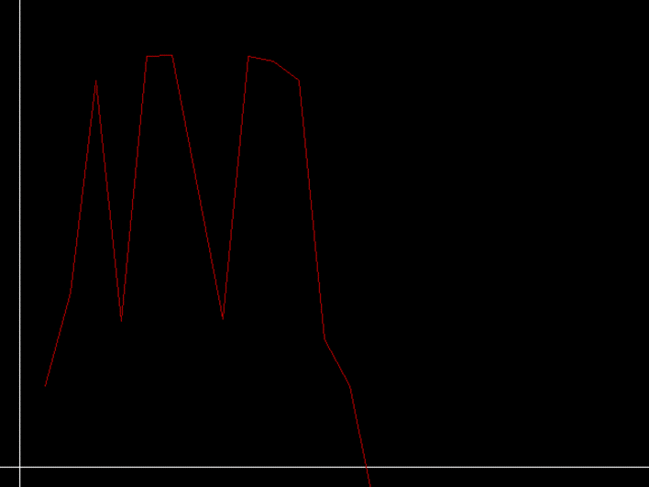

Fig 4.1: graph for sample test

**FOR GRAPH:**

The graph above illustrates the variation of simulated data of solar influx on flat plate collector. It can be note that cloudiness plays a crucial role in the performance of the system. The peak hours of solar radiation viz. 11 am, 12 pm and 1 pm, observe a severe depression, although being the hottest hours of day. This is due to the fact that the program simulated high cloudiness for these hours. Moreover, we can observe that there is a sudden break at the start and end of the graph, indicating the sunrise and sunset for the day.

The values of the various parameters are as follows:

|  |  |  |  |
| --- | --- | --- | --- |
| Time | Useful heat gain | FPC outlet temp | Chiller outlet temp |
| 6 am | 35.2765 | 61.01 | 7 |
| 7 am | 365.468 | 70.49 | 11 |
| 8 am | 1114.0879 | 91.98 | 7 |
| 9 am | 264.8386 | 67.60 | 12 |
| 10 am | 1198.4163 | 94.40 | 7 |
| 11 am | 1201.7915 | 94.50 | 7 |
| 12 am | 735.5596 | 81.12 | 9 |
| 1 pm | 268.8135 | 67.72 | 12 |
| 2 pm | 1198.4163 | 94.41 | 7 |
| 3 pm | 1181.9166 | 93.93 | 7 |
| 4 pm | 1114.0879 | 91.98 | 7 |
| 5 pm | 200.5187 | 65.75 | 12 |
| 6 pm | 35.2756 | 61.01 | 0 |
| 7 pm | -414.0514 | 48.11 | 0 |
| 8 pm | -659.5329 | 41.07 | 0 |

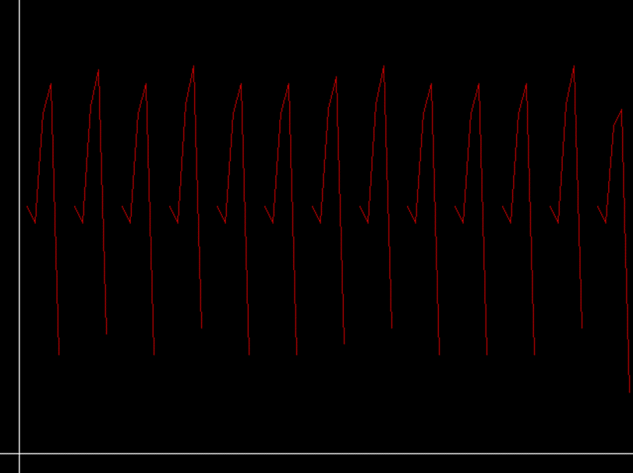

Fig 4.2: Thermal node variation graph

**FOR GRAPH:**

The second graph reveals the fact that system has to run only partially throughout the day length. The x-axis denotes the variation of time with 1 unit as 6 minutes. As seen shown above, the TES experience a high variation of temperature with time. The storage reaches the cutoff temperature at the end of every 50th minute approximately after which the inflow of cold liquid is stopped and the temperature rises until it reaches beyond the threshold value, after which it starts working again. Hence a cyclic nature is observed in the graph.

The simulated data and graphs illustrated above were calculated using the source code given below coded in c++.

#include<iostream.h>

#include<stdlib.h>

#include<conio.h>

#include<stdio.h>

#include<math.h>

#include<bios.h>

#include<graphics.h>

void main()

{

clrscr();

int n,w1,w2,stime,etime,time,tformat,j,num[50];

float m[25][10][6],outtemp,tcool[50],to1[50],to2[50],q[50],Ib[50],prob[5],refr1[50],k,tab[50],ta,s[50],tb[50],tr1,tr2,i,cosx[50],res,x[50],rb[50],w[50],refr[50],rho1[50],rho2[50],tr[50];

double t1[50],t2[50],t3[50],t4[50],t5[50],t6[50],tf[50],no;

cout<<"\nEnter the outdoor temperature:";

cin>>outtemp;

cout<<"\nEnter the start time:";

cin>>stime;

cout<<"choose-\n1 - am\n2 - pm\n";

cin>>tformat;

if(tformat==1)

w1=(12-stime)*15;

if(tformat==2)

w1=-stime*15;

cout<<"Enter the end time:";

cin>>etime;

cout<<"choose-\n1 - am\n2 - pm\n";

cin>>tformat;

if(tformat==1)

w2=(12-etime)*15;

if(tformat==2)

w2=-etime*15;

cout<<tformat<<"\nw1="<<w1<<"\nw2="<<w2;

cout<<"\nChoose the resolution of time line\n1-1 hour\n2-0.5 hour\n3-0.25 hour\n";

cin>>res;

if(res==1)

res=15;

if(res==2)

res=7.5;

if(res==3)

res=3.75;

n=(w1-w2)/res;

randomize(); //Random numbers code//

for(i=0;i<=n;i++)

{

num[i]=rand()%100;

}

cout<<"No. of steps="<<n;

for(i=w1,j=0;i>=w2;i=i-res,j++)

{

cosx[j]=0.007569+0.986898*cos((i*3.14)/180);

x[j]=acos(cosx[j]);

x[j]=(x[j]*180)/3.14; // The theta matrix in degrees //

w[j]=i; // The w matrix //

}

clrscr();

cout<<"\nEnter the cumulative probabilities for the day\n\nclear sky=";

cin>>prob[0];

prob[0]=prob[0]*100;

cout<<"\nmostly clear=";

cin>>prob[1];

prob[1]=prob[1]*100;

cout<<"\npartly cloudy=";

cin>>prob[2];

prob[2]=prob[2]*100;

cout<<"\nmostly cloudy=";

cin>>prob[3];

prob[3]=prob[3]*100;

cout<<"\novercast=";

cin>>prob[4];

prob[4]=prob[4]*100;

clrscr();

cout<<"\nEnter temp t1:";

cin>>t1[0];

cout<<"\nEnter temp t2:";

cin>>t2[0];

cout<<"\nEnter temp t3:";

cin>>t3[0];

cout<<"\nEnter temp t4:";

cin>>t4[0];

cout<<"\nEnter temp t5:";

cin>>t5[0];

cout<<"\nEnter temp t6:";

cin>>t6[0];

for(i=0;i<=20;i++) //Clearing the matrix//

Ib[i]=0;

for(i=0;i<=n;i++) //Sorting according to random numbers//

{

for(j=0;j<5;j++)

{

if(num[i]<=prob[j])

Ib[i]=Ib[i]+145;

}

}

for(i=0;i<=n;i++) // Output for theta costheta and w //

cout<<"\nx="<<x[i]<<"\tcosx="<<cosx[i]<<"\tw="<<w[i];

for(i=0;i<=n;i++) //Master loop for major iterative hourly calculations//

{

rb[i]=cosx[i]/(-0.017751+0.93151*cos((w[i]*3.14)/180));

refr1[i]=sin(x[i]*3.14/180)/1.51;

refr[i]=asin(refr1[i])*180/3.14;

rho1[i]=pow(sin(((x[i]-refr[i])*3.14)/180),2)/pow(sin(((x[i]+refr[i])*3.14)/180),2);

rho2[i]=pow(tan(((x[i]-refr[i])*3.14)/180),2)/pow(tan(((x[i]+refr[i])*3.14)/180),2);

tr1=(1-rho1[i])/(1+rho1[i]);

tr2=(1-rho2[i])/(1+rho2[i]);

tr[i]=(tr1+tr2)/2;

k=(-0.076/cos((x[i]/1.51)*3.14/180));

ta=pow(2.7182818,k);

tb[i]=ta*tr[i];

tab[i]=(tb[i]*0.95)/0.99295;

s[i]=(Ib[i]*tab[i]*rb[i])+(216.89+0.013*Ib[i])*0.737;

q[i]=1.79208*(s[i]-140);

to1[i]=(q[i]*0.014354)+60;

to2[i]=(q[i]*0.014354)+to1[i];

if((to2[i]>=90)&&(to2[i]<=95))

tcool[i]=7;

if((to2[i]>=85)&&(to2[i]<=89))

tcool[i]=8;

if((to2[i]>=80)&&(to2[i]<=84))

tcool[i]=9;

if((to2[i]>=75)&&(to2[i]<=79))

tcool[i]=10;

if((to2[i]>=70)&&(to2[i]<=74))

tcool[i]=11;

if((to2[i]>=65)&&(to2[i]<=69))

tcool[i]=12;

no=(13-tcool[i])/6;

tf[6]=tcool[i];

tf[5]=tf[6]+no;

tf[4]=tf[5]+no;

tf[3]=tf[4]+no;

tf[2]=tf[3]+no;

tf[1]=tf[2]+no;

for(j=0;j<=6;j++)

{

t1[j+1]=t1[j]-((360*((500*(t1[j]-t2[j])-300*(tf[j]-tf[j-1])))/100000));

t2[j+1]=t2[j]-((360*((500*(t2[j]-t3[j])-300*(tf[j]-tf[j-1])))/100000));

t3[j+1]=t3[j]-((360*((500*(t3[j]-t4[j])-300*(tf[j]-tf[j-1])))/100000));

t4[j+1]=t4[j]-((360*((500*(t4[j]-t5[j])-300*(tf[j]-tf[j-1])))/100000));

t5[j+1]=t5[j]-((360*((500*(t5[j]-t6[j])-300*(tf[j]-tf[j-1])))/100000));

}

for(j=0;j<=6;j++)

{

m[i][j][0]=t1[j];

m[i][j][1]=t2[j];

m[i][j][2]=t3[j];

m[i][j][3]=t4[j];

m[i][j][4]=t5[j];

m[i][j][5]=t6[j];

}

}

for(i=0;i<50;i++)

{

if(Ib[i]<0)

Ib[i]=0;

if(t1[0]<0)

t1[i]=0;

if(t2[0]<0)

t2[i]=0;

if(t3[0]<0)

t3[i]=0;

if(t4[0]<0)

t4[i]=0;

if(t5[0]<0)

t5[i]=0;

if(t6[0]<0)

t6[i]=0;

}

getch();

clrscr(); //Output verification code//

for(i=0;i<=n;i++)

cout<<"\nrb="<<rb[i];

getch();

clrscr();

for(i=0;i<=n;i++)

cout<<"\nrefr="<<refr[i]<<"\trho1="<<rho1[i]<<"\trho2="<<rho2[i]<<"\ttr="<<tr[i];

getch();

clrscr();

for(i=0;i<=n;i++)

cout<<"\ntab="<<tab[i];

getch();

clrscr();

cout<<"The values of incident flux:\n";

time=etime;

for(i=0;i<=n;i++)

{

if(stime<=12)

{

cout<<"\n"<<stime<<" am"<<"\tS="<<s[i]<<"\t"<<num[i]<<"\t"<<Ib[i]<<"\tq="<<q[i]<<"\tto="<<to2[i]<<"\tTABS="<<tcool[i];

stime++;

}

else

{

cout<<"\n"<<time-etime+1<<" pm"<<"\tS="<<s[i]<<"\t"<<num[i]<<"\t"<<Ib[i]<<"\tq="<<q[i]<<"\tto="<<to2[i]<<"\tTABS="<<tcool[i];

etime--;

}

}

getch();

clrscr();

for(i=0;i<=n;i++)

{

for(j=0;j<6;j++)

{

cout<<"\nt1="<<m[i][j][0]<<"\tt2="<<m[i][j][1]<<"\tt3="<<m[i][j][2]<<"\tt4="<<m[i][j][3];

}

getch();

}

getch();

clrscr();

int gd=DETECT,gm;

initgraph(&gd,&gm,"c:\\tc\\bgi");

line(0,460,640,460);

line(20,0,20,480);

setcolor(RED);

for(i=0;i<n;i++)

{

line(20+25+(i*25),460-(s[i]/2),20+25+((i+1)*25),460-(s[i+1]/2));

}

getch();

clrscr();

initgraph(&gd,&gm,"c:\\tc\\bgi");

line(0,460,640,460);

line(20,0,20,480);

for(i=0;i<n;i++)

{

for(j=0;j<4;j++)

{

setcolor(RED);

line(20+8+(i*48)+j*8,460-(m[i][j][0]*10),20+8+((i)*48)+(j+1)*8,460-(m[i][j+1][0]*10));

setcolor(BLUE);

line(20+8+(i*48)+j*8,460-(m[i][j][1]*10),20+8+((i)*48)+(j+1)*8,460-(m[i][j+1][1]*10));

setcolor(MAGENTA);

line(20+8+(i*48)+j*8,460-(m[i][j][2]*10),20+8+((i)*48)+(j+1)*8,460-(m[i][j+1][2]*10));

setcolor(YELLOW);

line(20+8+(i*48)+j*8,460-(m[i][j][3]*10),20+8+((i)*48)+(j+1)*8,460-(m[i][j+1][3]*10));

}

}

getch();

}

**CHAPTER :05**

**RESULTS AND CONCLUSION**

**5.1 Costing:**

cost of conventional HVAC system,

**1)Dry cool chiller system:**

18 lakh / unit of 400 TR

Total cost = 18*7= 1.26 crore

**2)Duct design:**

Area = 42*42 cm2

Perimeter = 2*(0.42+0.42) = 1.68 m

Total Area = 1.68(36+(13*4) +44*4) *2*5 =4435m2

cost of sheet = Rs 80/m2

Total cost of sheets = 4435*80 = Rs 354840

Lower diffuser cost = 60000

Total cost = Rs 414840

**3)AHU:**

Cost = Rs 50000/unit

No of units = 3

Total cost = 3*50000= 150000

Conventional system (neglecting pumps)

=126 lakh + 4.14 lakh + 1.5 lakh = 131.64lakh

Cost of non-conventional system

**1)Tabs calculations:**

Two types of modules

• 2000*600 = 8.44m*538*2*5

• 1800*600 = 7.64m*1744*2*5

Total = 178648.8m

1roll = 500m/roll63

Total roll required = 360 no.

Cost = Rs 55 / roll

Total Cost = Rs 4125000

**2)Flat plate collectors:**

Total no of FPC = 400

Cost of single FPC (including all types of cost) = Rs 9000 (Kingspan)

Total cost = Rs 36,00,000

**3)Absorption chiller:**

Absorption chiller = 8lakhs/unit (bryair)

Total cost = 8*3 = 24 lakhs

Cost of non-conventional system

= 24lakh + 36 lakh + 41.25 lakh

= 101.25 lakh

**5.2 RESULT:**

From this project we got the following result,

First of all, this project deals with designing of conventional HVAC system along with non-conventional HVAC system. This is not only cost effective but also effective in the process of heating and cooling.

The heat load calculation results were as follows

Total load for all the rooms =2126TR

Total heat load for Atrium = 114TR

Total heat load for corridor = 94 TR

The result obtained from conventional technique:

* Glass selection: Double glazed glass, low e & laminated, Pristine white-code PLTT, transmission 74%, SHGC 0.54
* Cooling unit selection: Air cooled screw chiller with adiabatic kit. 400TR 6W+1SB, All VFD. 1W+1SB 200TR Air cooled screw chiller for Precision AHU
* Automation: Chiller plant manager with provision for BMS connectivity

The results obtained from non-conventional techniques:

* Glass selection: The new glass with film which is to be proposed

SCWF (Solar Control window film) with SHGC VALUE= 0.26

4mm thick clear window glass.

* TABS: the results are as follows

|  |  |  |  |
| --- | --- | --- | --- |
| **Office** | **No. of modules** | | **Q** |
| **1800** | **2000** |
| 1B | 424 | 202 | 162.3kw |
| 2B | 180 | 335 | 137.8kw |
| 3B | 570 | 0 | 143.07kw |
| 4B | 570 | 0 | 143.07kw |

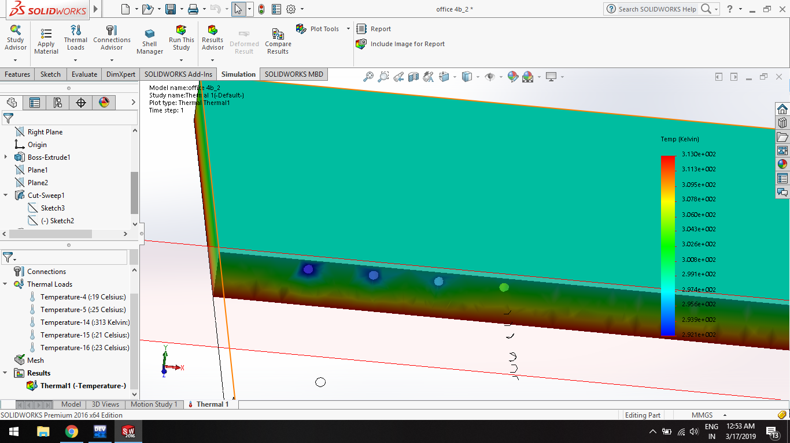

* Flat Plate Collector:

Water outlet temp for single stage: 75OC

Water outlet temp for double stage: 100.75OC

* Thermal Energy Storage

|  |  |
| --- | --- |
| **Specifications** | **Design** |
| No. of tanks | 2 |
| Storage capacity | 75000 m3 (i.e. 75kgs of water) |
| Hot/Cold heat exchanger type | Bell Gosett BPX braze plate exchanger |
| Insulation | Flexible polyurethane drop-in liner |
| Wall thickness | 0.3 m |
| Dimensions | 5m x 5m x 3m |

Costing results

* Conventional system (neglecting pumps)

=126 lakh + 4.14 lakh + 1.5 lakh = 131.64lakh

* Cost of non-conventional system

= 24lakh + 36 lakh + 41.25 lakh

= 101.25 lakh

Simulation results

The scope of this chapter is to analyse the **ISAAC system** on various parameters such as the cooling water of TABS, power required to run the system, etc. The system was simulated on **15th of March, 2019** the results of which were discussed in earlier chapters. The efficiency of TABS can be determined by calculating the fraction of time for which the **temperature of TES falls below 190C**, as it acts as the **inlet for the cooling coil for TABS**.

The following table and graphs illustrate **the hourly and overall efficiency of system** as on 15th March, 2019.

|  |  |
| --- | --- |
| Time | Efficiency % |
| 6 am | 19.629 |
| 7 am | 42.346 |
| 8 am | 93.950 |
| 9 am | 35.432 |
| 10 am | 99.753 |
| 11 am | 100.000 |
| 12 am | 67.901 |
| 1 pm | 35.802 |
| 2 pm | 99.753 |
| 3 pm | 98.642 |
| 4 pm | 93.951 |
| 5 pm | 30.988 |
| 6 pm | 19.629 |
| 7 pm | 0.000 |
| 8 pm | 0.000 |

**COMPARISION:**

|  |  |  |
| --- | --- | --- |
| **Parameters** | **Conventional** | **Non-conventional** |
| Glass | Uses glass of SHGC value 0.54, DGU | Uses glass of SHGC value 0.26, DGU |
| Cooling unit selection | Air cooled screw chiller of 400 TR, 7 units VCR | Adsorption chiller of 300 TR, 6 units |
| Installation cost | 131lakh | 101lakh |
| Running and maintenance cost | More | Less |
| Power required | electricity | Solar energy or electricity |
| Leakage problem | More often | Less often |
| Hazardous to environment | Yes | No |
| Life expectancy | Less | More |
| Refrigerant use | R410a ,R134a,R123 | Water and silica gel |

**5.3 CONCLUSION:**

From this we can conclude that as the system runs on an average efficiency of 55.85%, we have to aid the ISAAC system with an auxiliary system. The load can divide between the conventional and non-conventional system as 45:55 ratio. As the energy required to drive the system is derived from sun, the energy is free of cost. Hence, it can be concluded that the ISAAC system reduces 55% of the total energy requirement.

The ISAAC system is comparatively cheaper than the conventional HVAC system. It draws energy from the sun hence greatly reduces the cost of electricity, also the running and maintenance cost is lower for the ISAAC compare to conventional one.

As the ISAAC system depends less on the conventional system, its impact on the environment is much better. The installation of such a system is a step towards environment protection.

**REFERENCES**

1.Solar Energy: Principles of Thermal Collection and Storage book by K.Sukhatme and Suhas Pandurang Sukhatme

2.HVAC Engineer’s Handbook – 2014 (revision) by ISHRAE

3.Meierhans R.A., Slab cooling and earth coupling, ASHRAE Transactions, 100 (1994), p. 511-518

4.Meierhans R.A., Room air conditioning by means of overnight cooling of the concrete ceiling, ASHRAE Transactions, 102(1996), p. 693-69

5. B.W. Olesen, M. de Carli, M. Scarpa and M. Koschenz, Dynamic evaluation of the cooling capacity of thermo-active builing systems, ASHRAE Transactions, 112 (2006), p. 350-357

6. B.W. Olesen and F. C Dossic, Operation and control of activated slab heating and cooling systems, Proceedings of CIB World Buildings Congress 2004

7.Jakub Kolarik, Jørn Toftum, Bjarne W. Olesen and Kasper L. Jensen, Simulation of energy use, human thermal comfort and office work performance in buildings with moderately drifting operative temperatures, Energy and Buildings, 43 (2011), p. 2988-2997

8.Sang Hoon Park, Woong June Chung, Myoung Souk Yeo and Kwang Woo Kim, Evaluation of the thermal performance of a thermally activated building system (TABS) according to the thermal load in a residential building, Energy and Buildings, 73 (2014), p. 69-82

9.Jan Babiak, Bjarne W. Olesen and Dusan Petras, Low temperature heating and high temperature cooling, embedded water-based surface heating and cooling system, REHVA Technical Task Force 3, 2009

10. ISO 7730, Ergonomics of the thermal environmentˉAnalytical determination and interpretation of thermal comfort using calculation of the PMV and PPD indices and local thermal comfort criteria, 2005

11.H.N. Knudsen, R.J. de Dear, J.W. Ring, T.L. LI, T.W. Puntener and P.O. Fanger, Thermal comfort in passive solar buildings, Final report.

12.Meierhans R.A., Slab cooling and earth coupling, ASHRAE Transactions, 100 (1994), p. 511-518

13.Case study on zero energy building of berekely p. 69-72

or single floor

14.ISHRAE Weather Data 2014 (new)

15. Passive cooling techniques through reflective and radiative roofs in tropical houses in Southeast Asia: A literature review, School of Housing, Building and Planning, Universiti Sains Malaysia, Penang 11800, Malaysia.

16. Energy consumption analysis of HVAC system with respect to zone temperature and humidity set-point, Proceedings of the 18th World Congress, The International Federation of Automatic Control, Milano (Italy) August 28 - September 2, 2011.

17. Modeling of a solar-assisted HVAC system with thermal storage.

M. Ortiz, H. Barsun, H. He, P. Vorobieff_, A. Mammoli,The University of New Mexico, Albuquerque, New Mexico 87131, USA

18. Optimization of Different Parameter of Cold Storage for Energy Conservation, International Journal of Modern Engineering Research (IJMER)Vol.2, Issue.3, May-June 2012 pp-1001-1005

19. Predictive pre-cooling of thermo-active building systems with low-lift chillers, Taylor Francis journal

20. A Comprehensive Review of Thermal Energy Storage, Sustainability, Published: 14 January 2018.

21. A simple mathematical model for evaluating the effectiveness of solar water heating system with thermosyphon heat exchanger, International Journal of Mechanical Engineering ISSN : 2277-7059 Volume 2 Issue 8 (August 2012)

**BIBLIOGRAPHY**

[www.energysources.com](http://www.energysources.com)

[www.google.com](http://www.google.com)

[www.indiamart.com](http://www.indiamart.com)

[www.wikipedia.com](http://www.wikipedia.com)

[www.bankbazar.com](http://www.bankbazar.com)

[www.bijlibachao.com](http://www.bijlibachao.com)

[www.synergyenviron.com](http://www.synergyenviron.com)

[www.weatherspark.com](http://www.weatherspark.com)

[www.elsevier.com](http://www.elsevier.com)

[www.sciencedirect.com](http://www.sciencedirect.com)

[www.researchgate.net](http://www.researchgate.net)

[www.energyinformative.org](http://www.energyinformative.org)

[www.energyskeptic.com](http://www.energyskeptic.com)

[www.ijmer.com](http://www.ijmer.com)